*Florida International University*

*School of Computing and Information Sciences*

Software Engineering Focus

*Final Deliverable*

Mobile Judge 10.0

**Team Members:** Pablo Alcocer, Alberto Camacho, Shahinaz Elmahmoudi, Guillermo Matos

**Product Owner**: Masoud Sadjadi

**Mentor**: Masoud Sadjadi

**Instructor**: Masoud Sadjadi, Francisco Ortega

The MIT License (MIT)

Copyright (c) *2016 Florida International University*

Permission is hereby granted, free of charge, to any person obtaining a copy of this software and associated documentation files (Mobile Judge), to deal in the software without restriction, including without limitation the rights to use, copy, modify, merge, publish, distribute, sublicense, and/or sell copies of Mobile Judge, and to permit persons to whom Mobile Judge is furnished to do so, subject to the following conditions:

The above copyright notice and this permission notice shall be included in all copies or substantial portions of Mobile Judge.

MOBILE JUDGE IS PROVIDED "AS IS", WITHOUT WARRANTY OF ANY KIND, EXPRESS OR IMPLIED, INCLUDING BUT NOT LIMITED TO THE WARRANTIES OF MERCHANTABILITY, FITNESS FOR A PARTICULAR PURPOSE AND NONINFRINGEMENT. IN NO EVENT SHALL THE AUTHORS OR COPYRIGHT HOLDERS BE LIABLE FOR ANY CLAIM, DAMAGES OR OTHER LIABILITY, WHETHER IN AN ACTION OF CONTRACT, TORT OR OTHERWISE, ARISING FROM, OUT OF OR IN CONNECTION WITH MOBILE JUDGE OR THE USE OR OTHER DEALINGS IN MOBILE JUDGE.

***Abstract***

*This document presents the required information to have a general understanding of the current system of Mobile Judge as well as the changes made in the latest program increment. This final document will begin by discussing the current system of Mobile Judge and then discuss the newest changes known as Mobile Judge 10.0. The user stories which were created throughout the semester will be defined and the user stories that are still pending are discussed. Finally, the document will outline the product plan, system design, and system verification. These three topics will provide the grand picture of the issues fixed in the current system and the new features or fixes that are to be added to the current system.*

**Table of Contents**

**Introduction**……………………………………………………………………………………5

Current System...………………….………………………………………………………... 5

Purpose of New System…………………………….……………………………………...... 6

**User Stories**

Implemented User Stories...……….……………………………………….……….………. 9

Pending User Stories ...…………………………………………………….…………..….. 12

**Project Plan**

Hardware and Software Resources ………………………………………………………. 13

Sprints Plan .………………………………………………………………………………. 15

*Sprint 1*  .……………………………………………………………….………………... 15

*Sprint 2*  ….…………………...…………………………………………………………. 15

*Sprint 3*  .…………………………………………………………….…………………... 19

*Sprint 4*  .……………………………………………………………………………….... 22

*Sprint 5*  ………………………………………………………………….…………........ 25

*Sprint 6*  ….……………………………………………………………………….……... 25

**System Design**

Architectural Patterns …….…………...……………………………………………….. 26

System and Subsystem Decomposition ………………………...……………………….… 26

Deployment Diagram …………………………………………………………….………. 28

Design Patterns ..…………………………………………………………………….….... 28

**System Validation**  ……....…………………………………………………………………. 29

**Appendix** ………………………………..……………………………………………………**.** 59

Appendix A - UML Diagrams …………………………………………………………...… 60

Appendix B - User Interface Design ………………........…………………………….…... 81

Appendix C - Sprint Review Reports ………………………………………………...….… 90

Appendix D - User Manuals, Installation/Maintenance Document, Shortcomings/Wishlist Document and other documents ……………………………………………….………… 93

**References** ……….…………………………………………………………………...…..…101

# Introduction

The introduction section will provide an overview of the current system. This section will provide an explanation of the current system’s shortcomings and areas that need to be improved. Mobile Judge was created in order to automate the laborious details of the senior showcase hosted every semester at Florida International University. The Mobile Judge system allows students to see their grades assigned by judges. The judges are assigned a maximum of five students to grade and they get a very friendly user experience. An administrator can change some details of the system, send mass emails, accept grades from judges, view statistics of a current or previous semester and a host of other features. An administrator's workload is drastically reduced when using the system for the showcase from the beginning with the invites and ending with grade assignments.

The rest of the document will provide an overview about the latest development for the Mobile Judge system including user stories, object diagrams and sequence diagrams. The testing of the new features will also be detailed to ensure a functional production environment while the showcase is live.

## 

## Current System

The current system is in its tenth iteration also known as Mobile Judge 10.0 was built using Sencha ExtJS, which is a merge of ExtJS and Sencha Touch 2. Mobile Judge 10.0 has a host of many features that make the senior project showcase easier to organize which is helped with its very friendly user experience. The user system had some rendering defects and a lack of options to view which judge was assigned to whichstudents and vice versa. The mobile version of Mobile Judge 9.0 was limited as well as few views were implemented giving the mobile site an empty feel. Mobile Judge 10.0 makes logging in with third party accounts such as Facebook, Twitter, FIU accounts an easy task with the use of OAuth. OAuth is a type of authentication software used in many software systems today.The system also assigns students to their judges who will be grading them. Once a judge accepts an invite, they are automatically assigned a student. One problem with the current invitation system is that the judge can accept the invite but never make it to the actual event, leaving a student with a missing judge.The system comes with the standard password recovery features in the case that a user forgets their password. There are four types of actors in Mobile Judge 10.0: students, judges, unregistered judges and administrators.

One of the biggest features of Mobile Judge 10 is the email feature that gives an administrator an easy way to send mass emails to students currently in the senior project or VIP courses and even sending personalized emails to prospective judges once they accept, reject, or asked to be removed from the mailing list. It makes managing the class and the senior project showcase much easier. Administrators can also manage term settings, and view statistics of the current and previous terms. Administrators can also assign grades from within the system.

When logged in as a judge, the user can see an event map, the students they have been assigned to and a view that allows a judge to assign student grades. Judges are given five questions that they are to answer using a numerical scale from 1 to 10 for each of their assigned students. The numerical grading comes in the form of an easy to use slider control. Judges can also leave text based feedback if they want to elaborate on a grade their gave a student.

Students have a simplest user interface of all three actors and it is basically two views. One view will tell them their location for the senior project showcase and in event map in the case they don’t know where to go. Students can also see their overall grade once they have been approved by the administrator.

## Purpose of New System

The new system adds more features in order to make the managing the senior showcase easier for the administrator. New features of the system are described in the next page and were mainly for improving the administrative user experience.

* Add new mobile functionality for the administrative settings tab
  + Allow administrator to modify the settings of a semester such as the maximum number of judges, enable judge login, student's grade publishing.
  + Allow an administrator to switch terms to view past data within in system.
  + Allow an administrator to create or delete terms when necessary.
  + Allow an administrator to create, delete, and edit the questions that judges will ask at a senior project showcase.
* Change the registration process to occur on-site
  + Acceptance link from invitation email redirects to static page
  + Allow the administrator to switch the templates for the acceptance email
  + Email confirmation send to the invited judge upon acceptance
  + Add a new user type that manages the on-site registration process
  + Allow the pending judges to register by finding their names in a list
* Show charts with data about grades given to students by judges
  + Different types of graphs for different users
  + Give administrator insights as to what is happening during the showcase
  + Give students insights as to their strengths and weaknesses during the showcase
  + Allow administrator to view all grades for an active semester to streamline the grading process.
* Allow administrator to view all grades for an active semester to streamline the grading process.
  + View students by judge in order to be able to view and pend/acc/deny all of a single judge’s decision
  + Allows administrator to view a specific student’s feedback by a particular judge
  + Allows an administrator to pend/acc/deny a single student in the judge's view
  + Allows for a new semester to be free of students with prior grades

These new features provided by the team should allow to the administrator to navigate the website in an easier and more convenient manner. They will also allow an administrator see more data in an easy to read view. The staggered judge assignments to students will also ensure a smoother showcase since all judges that have been assigned students will be at the event. No students will be ever be left without any judges.

On the mobile version of the website, the settings tab has two new sub views, namely settings and questions. The settings tab allows an administrator to create, delete, and edit terms. The questions tab allow the administrator to create, delete, and edit questions. This new functionality lets the administrators to make the above changes when they are away from their desktop.

As an administrator new features for the grades tab has been added in order to better monitor a judge’s decision. If one notices that they are being too difficult or too lenient then an admin can now step in and check all of the students assigned to that judge and be able to make a global or case by case decision right from the menu. The admin can also click on an individual student in that same view and see the feedback that the assigned judge had given. It is the opposite view of the students tab. The bug that would add students from prior semesters because they had grades in the system was fixed allowing administrators to be able to start every semester fresh.

# User Stories

The following section provides the detailed user stories that were implemented in this iteration of the Mobile Judge project. These user stories served as the basis for the implementation of the project’s features. This section also shows the user stories that are to be considered for future development.

## Implemented User Stories

#682 - Research Implementation

As a developer, I need to become familiar with the implementation of Mobile Judge 9.0.

#683 - Install Mobile-Judge-9.0 into Workstation

As a developer, I need to install Mobile-Judge-9.0 into my workstation to being developing.

#684 - Mobile UI Debugging for iPad

As a developer, I need to find any existing defects in the iPad user interface so that the existing defects can be resolved.

#685 - Research Sencha charts for Data Visualization

As a developer, I need to research the D3 framework so that I can display data in a graphical manner.

#686 - Research the email system

As a developer, I need to be able to understand the implementation of the email system in its current state so that i can improve upon the email system.

#687 - Research Student Implementation for Views

As a developer, I want to study the implementation for the student views so that I can implement the judge view.

#689 - Get Production and Dev sites up

As a user, when I visit mj-dev.cis.fiu.edu or mj.cis.fiu.edu, I want to see the website.

#693 - Judge View by Students

As an admin, I want to be able to to click on a judge and see a list of students that the judge was assigned, so that I can easily disqualify a judge.

As an admin, I want to be able to click on each student, so that I can see the scores given per question.

#694 - Accept Judge Invitation

As an invited judge, if I accept the invitation, I would like to be directed to a placeholder page that indicates my acceptance of the invitation and receive a confirmation email, so that I am sure my decision is recorded by the system.

#696 - New Registration Process

As a potential Judge, I want to be able to click on my name and be redirected to a registration page where I am able to register, so that I will be assigned students to judge

#653 - Add downloadable template for Judges

As an admin, I would like to be able to download a sample filer to fill out so that I can easily upload it back to the system.

#698 - Creates Stats View

As a Student, I want to see a ‘Stats’ page, so that I can visualize the grades given to me.

As a Judge, I want to see a ‘Stats’ page, so that I can visualize the grades I have given.

As an Admin, I want to see a ‘Stats’ page, so that I may be aware of grades being given at the showcase.

#699 - Fix DB Update

As an Admin, I want to be able to start a new semester with blank records, so that students who have taken VIP Junior do not populate the current term with old data.

#700 - Create Live Graphs for Admins

As an Admin, I want to see different data visualizations pertaining to the averages of student grades and judge grades, so that I may be aware of grades being given at the showcase

#701 - Create Live Graphs for Students

As a Student, I want to see my grades live at the showcase, so that I can be aware of my grade.

As a Student, I want to see anonymized grades of other students, so that I may be aware of how I’ve done versus other students.

#702 - Fix Stop Light Issues

As an admin, I want to be able to see an interactive light that will change to the proper colors whenever a judge has an Accepted (green), Pending (yellow), or Rejected (red) grade, or any combination of them depending on each student in the list.

#703 - Change Terms on Mobile Settings

As an admin, I would like to change the current term so that I can access other term information.

#704 - Create Terms on Mobile Settings

As an admin, I would like to add new terms in the settings so that I can continue using Mobile Judge in future semesters.

#705 - Delete Terms on Mobile Settings

As an admin, I would like to delete a term in the case that the term is not needed to be stored anymore.

#706 - Add Questions on Mobile Settings

As an admin, I would like to add more questions the judges can ask students during the senior project showcase

#707 - Edit Questions on Mobile Settings

As an admin, I want to be able to edit existing questions so that I can improve questions being asked.

#708 - Delete Questions on Mobile Settings

I would like to delete questions in the case that they are not needed anymore so that I can make room for better questions.

#709 - Unregistered Judge User

As an unregistered judge, I want to be able to login into the website to finish my registration.

#710 - Unregistered Judge Tab View

As an unregistered judge that logged into the website I want to be able to find myself in a list of all the pending judges.

#711 - Test and Fix Defects for Admin Settings Page

As an Admin, I want to be able to access the settings page on mobile without the web page breaking.

#714 - Average grade per question for all students (Admin view)

As an admin, I want to see a bar graph of the average grade per question given to a student, so that I may be aware of grades being given at the showcase.

#715 - Average grade per question for one student (Student view)

As a student, I want to see a bar graph of my average grade of the grades being given at the showcase.

#716 - Average grade per question for one judge (Judge View)

As a judge, I want to see a bar graph of my assigned grades as I grade students.

#722 - Average Grade per Project

As an admin, I want to see a bar graph of the average grade per project, so that I may be aware of grades being given at the showcase.

#723 - Average Grade per Question for all Judges

As an admin, I want to see a bar graph of the average grade given by judges, so that I may be aware of grades being given at the showcase.

## Pending User Stories

#713 - Add live stats of grades

As an admin, I would like to be able to have one or more classes per semester supported in the system, so that I can separately assign questions for judges for each specific class and get report for the grades separately based on each class.

# Project Plan

This section describes the planning that went into the realization of this project. This project incorporated the agile development techniques and as such required the sprints to be planned. These sprint plannings are detailed in the section. This section also describes the components, both software and hardware, chosen for Mobile Judge. Since, we are just adding new features.

## Hardware and Software Resources

The following is a list of all hardware and software resources that were used in this project:

**MySQL & MariaDB**MySQL was used for persistent data storage system because of the inherent benefits of a structure query language, security and speed that Mobile Judge requires, in addition to its large support and user-base. MariaDB is the server for the database.

**phpMyAdmin**

Database Management System used to view and manipulate the data in the database.

**Sencha**

The framework Mobile Judge was built on that is a user interface JavaScript library and web framework, that would allow mobile and cross platform capabilities.

**Sencha CMD**

Sencha CMD used because it is the cornerstone for building Sencha ExtJS and Sencha Touch applications, as well as optimizing ExtJS applications.

**WebStorm**

The IDE we used to develop code for Mobile Judge. Webstorm was chosen because of the integration it has with Sencha ExtJS.

**NodeJS**

The run-time environment for executing JavaScript code server-side. Node is intended to run on a dedicated HTML server, which in our case is NGINX.

**OAuth**

OAuth.io allows you to integrate 100+ providers really easily in your web app, without worrying about each provider's OAuth specific implementation. This is how we were able to allow logins from FIU, Gmail, LinkedIn, Twitter, and Facebook.

**PM2**

PM2 was utilized as a production process manager for the Node.js applications with a built-in load balancer. It allows applications to stay alive forever, to reload them without downtime, and to facilitate common system admin tasks straight from the terminal command line or from <https://keymetrics.io/>.

**Ubuntu**

Ubuntu is the operating system where the production application has been hosted from and since it can be easily install all the various softwares required to run this application.

**NGINX**

NGINX was used as the HTTP server and reverse proxy for Mobile Judge, also it is known for its high performance, stability, rich feature set, simple configuration, and low resource consumption.

**phpMyAdmin**

phpMyAdmin is a DBMS that is being used to view and manipulate the data in the database and can be accessed remotely.

**Grunt**

Grunt is a tool used to automatically perform frequently used tasks such as minification, compilation, unit testing, linting, etc. It uses a command-line interface to run custom tasks defined in a file

**Git**

Git is being used for code management and version control.

## Sprints Plan

### Sprint 1

**User Story #682 - Research Implementation**

As a developer, I need to become familiar with the implementation of Mobile Judge 9.0.

### Sprint 2

**User Story #682 - Research Implementation**

As a developer, I need to become familiar with the implementation of Mobile Judge 9.0.

**User Story #684 - Mobile UI Debugging for iPad**

As a developer, I need to find any existing defects in the iPad user interface so that the existing defects can be resolved.

**Acceptance Criteria:**

* Find any defects in the iPad version of Mobile Judge

**User Story #686 - Research the email system**

As a developer, I need to be able to understand the implementation of the email system in its current state so that i can improve upon the email system.

### 

### Sprint 3 **User Story #693 - Judge View by Students**

As an Admin, I want to be able to click on a judge and see a list of students that the judge has assigned, so that I can easily disqualify a judge. As an Admin, I want to be able to click on each student, so that I can see the scores given per question.

**Acceptance Criteria:**

* Second view loads correctly
* Third view loads correctly
* Ability to accept/reject grades given by a judge

**User Story #694 - Accept Judge Invitation**

As an invited judge, if I accept the invitation, I would like to be directed to a placeholder page that indicates my acceptance of the invitation and receive a confirmation email, so that I am sure my decision is recorded by the system.

**Acceptance Criteria:**

* Acceptance link redirects to static page
* Judge placed in pending status
* Students are NOT assigned to judge
* An email confirmation is sent to the judge.

**User Story #699 - Fix DB Update**

As an Admin, I want to be able to start a new semester with blank records, so that students who have taken VIP Junior do not populate the current term with old data

**Acceptance Criteria:**

* Students who have taken VIP before should not show up in the grades tab with their old grades.
* Students who have taken VIP before should not show up in the people tab with their old locations.

### 

### Sprint 4User Story #702 - Fix Stop List Issues

As an admin, I want to be able to an interactive light that will change to the proper colors whenever a judge has an Accepted (green), Pending (yellow), or Rejected (red) grade, or any cobination of them depending on each student in the list.

**Acceptance Criteria:**

* Stoplight automatically updates after clicking on the view and changing a student’s status and exiting the view.
* Stoplight at the top of the view when clicking on the judge works properly
* Global changes work properly and update everything accordingly

### User Story #703 - Change Terms on Mobile Settings

As an admin, I would like to be able to change the current term so that I can access other information.

**Acceptance Criteria:**

* Changing terms on the mobile settings page by tapping on a dropdown menu.
* A confirmation button to change semesters.
* Compatibility on Safari for iPhones and Chrome for Android.

**User Story #704 - Create Terms on Mobile Settings**

As an admin, I would like to add new terms in the settings so that I can continue using Mobile Judge in future semesters.

**Acceptance Criteria:**

* A button labeled new can be pressed and presents a form with blank term information to be filled out and saved.
* Work properly on iPhones running on Safari and Android running on Chrome.

**User Story #705 - Delete Terms on Mobile Settings**

As an admin, I would like to be able to delete a term in the case that the term is not needed to be stored anymore.

**Acceptance Criteria:**

* A button labeled delete can be pressed with a selected item that is not the active term and delete the unwanted term.
* Work properly on iPhones running Safari and Chrome running on Android.

**User Story #706 - Add Questions on Mobile Settings**

As an admin, I would like to add more questions the judges can ask students during the senior project showcase.

**Acceptance Criteria:**

* Add a new question by pressing a button which adds a new record that can be edited after with the new questions information.
* Compatibility with Safari on iPhone and Chrome on Android.

**User Story #707 - Edit Questions on Mobile Settings**

As an admin, I want to be able to edit existing questions so that I can improve the questions being asked.

**Acceptance Criteria:**

* Edit a new question by pressing a button which adds a new record that can be edited after with the new questions information.
* Compatibility with Safari on iPhone and Chrome on Android.

**User Story #708 - Delete Questions on Mobile Settings**

As an admin, I would like to delete questions in the case that they are not needed anymore so that I can make room for better questions.

**Acceptance Criteria:**

* A button to delete a selected question.
* Compatibility with Safari on iPhone and Chrome on Android.

**User Story #709 - Unregistered Judge User**

As a pending judge who accepted the invitation, but not finished my registration, I want to be able to login into a the unregistered judge account finish my registration at the checkin desk.

**Acceptance Criteria:**

* Unregistered Judge user able to login
* Username is [judge@fiu.edu](mailto:judge@fiu.edu), password is 123

**User Story #710 - Unregistered Judge View**

As an unregistered judge that logged in to the website I want to be able to find myself in a list of all the pending judges.

**Acceptance Criteria:**

* Unregistered Judge Tab is created
* User able to see all the pending judges including himself

### Sprint 5

**User Story #696 - New Registration Process**

As a potential Judge, I want to be able to click on my name and be redirected to a registration page where I am able to register, so that I will be assigned students to judge.

**Acceptance Criteria:**

* Judge status changes from pending to accepted
* Students are assigned to judge
* Judges able to login

**User Story #711 - Test and Fix Defects for Admin’s Settings Page**

As an admin, I want to be able to access the setting page on mobile without the web page breaking.

**Acceptance Criteria:**

* The mobile settings view must execute consistently.
* The mobile settings view must not freeze when using it.

### Sprint 6

In Sprint 6, the time is devoted to finishing/organizing deliverables and creating the following videos:

* Introductory Video
* Tutorial for Each Actor
* Installation and Maintenance
* Shortcomings & Wishlist

# System Design

This section contains information on the design decisions that went into Mobile Judge. The architecture patterns are outlined and explained. The entire system is shown in a package diagram and the subsystems are explained. Finally, the design patterns used in the project are discussed. Mobile Judge implements the Model View Controller (MVC) Model.

## Architectural Patterns

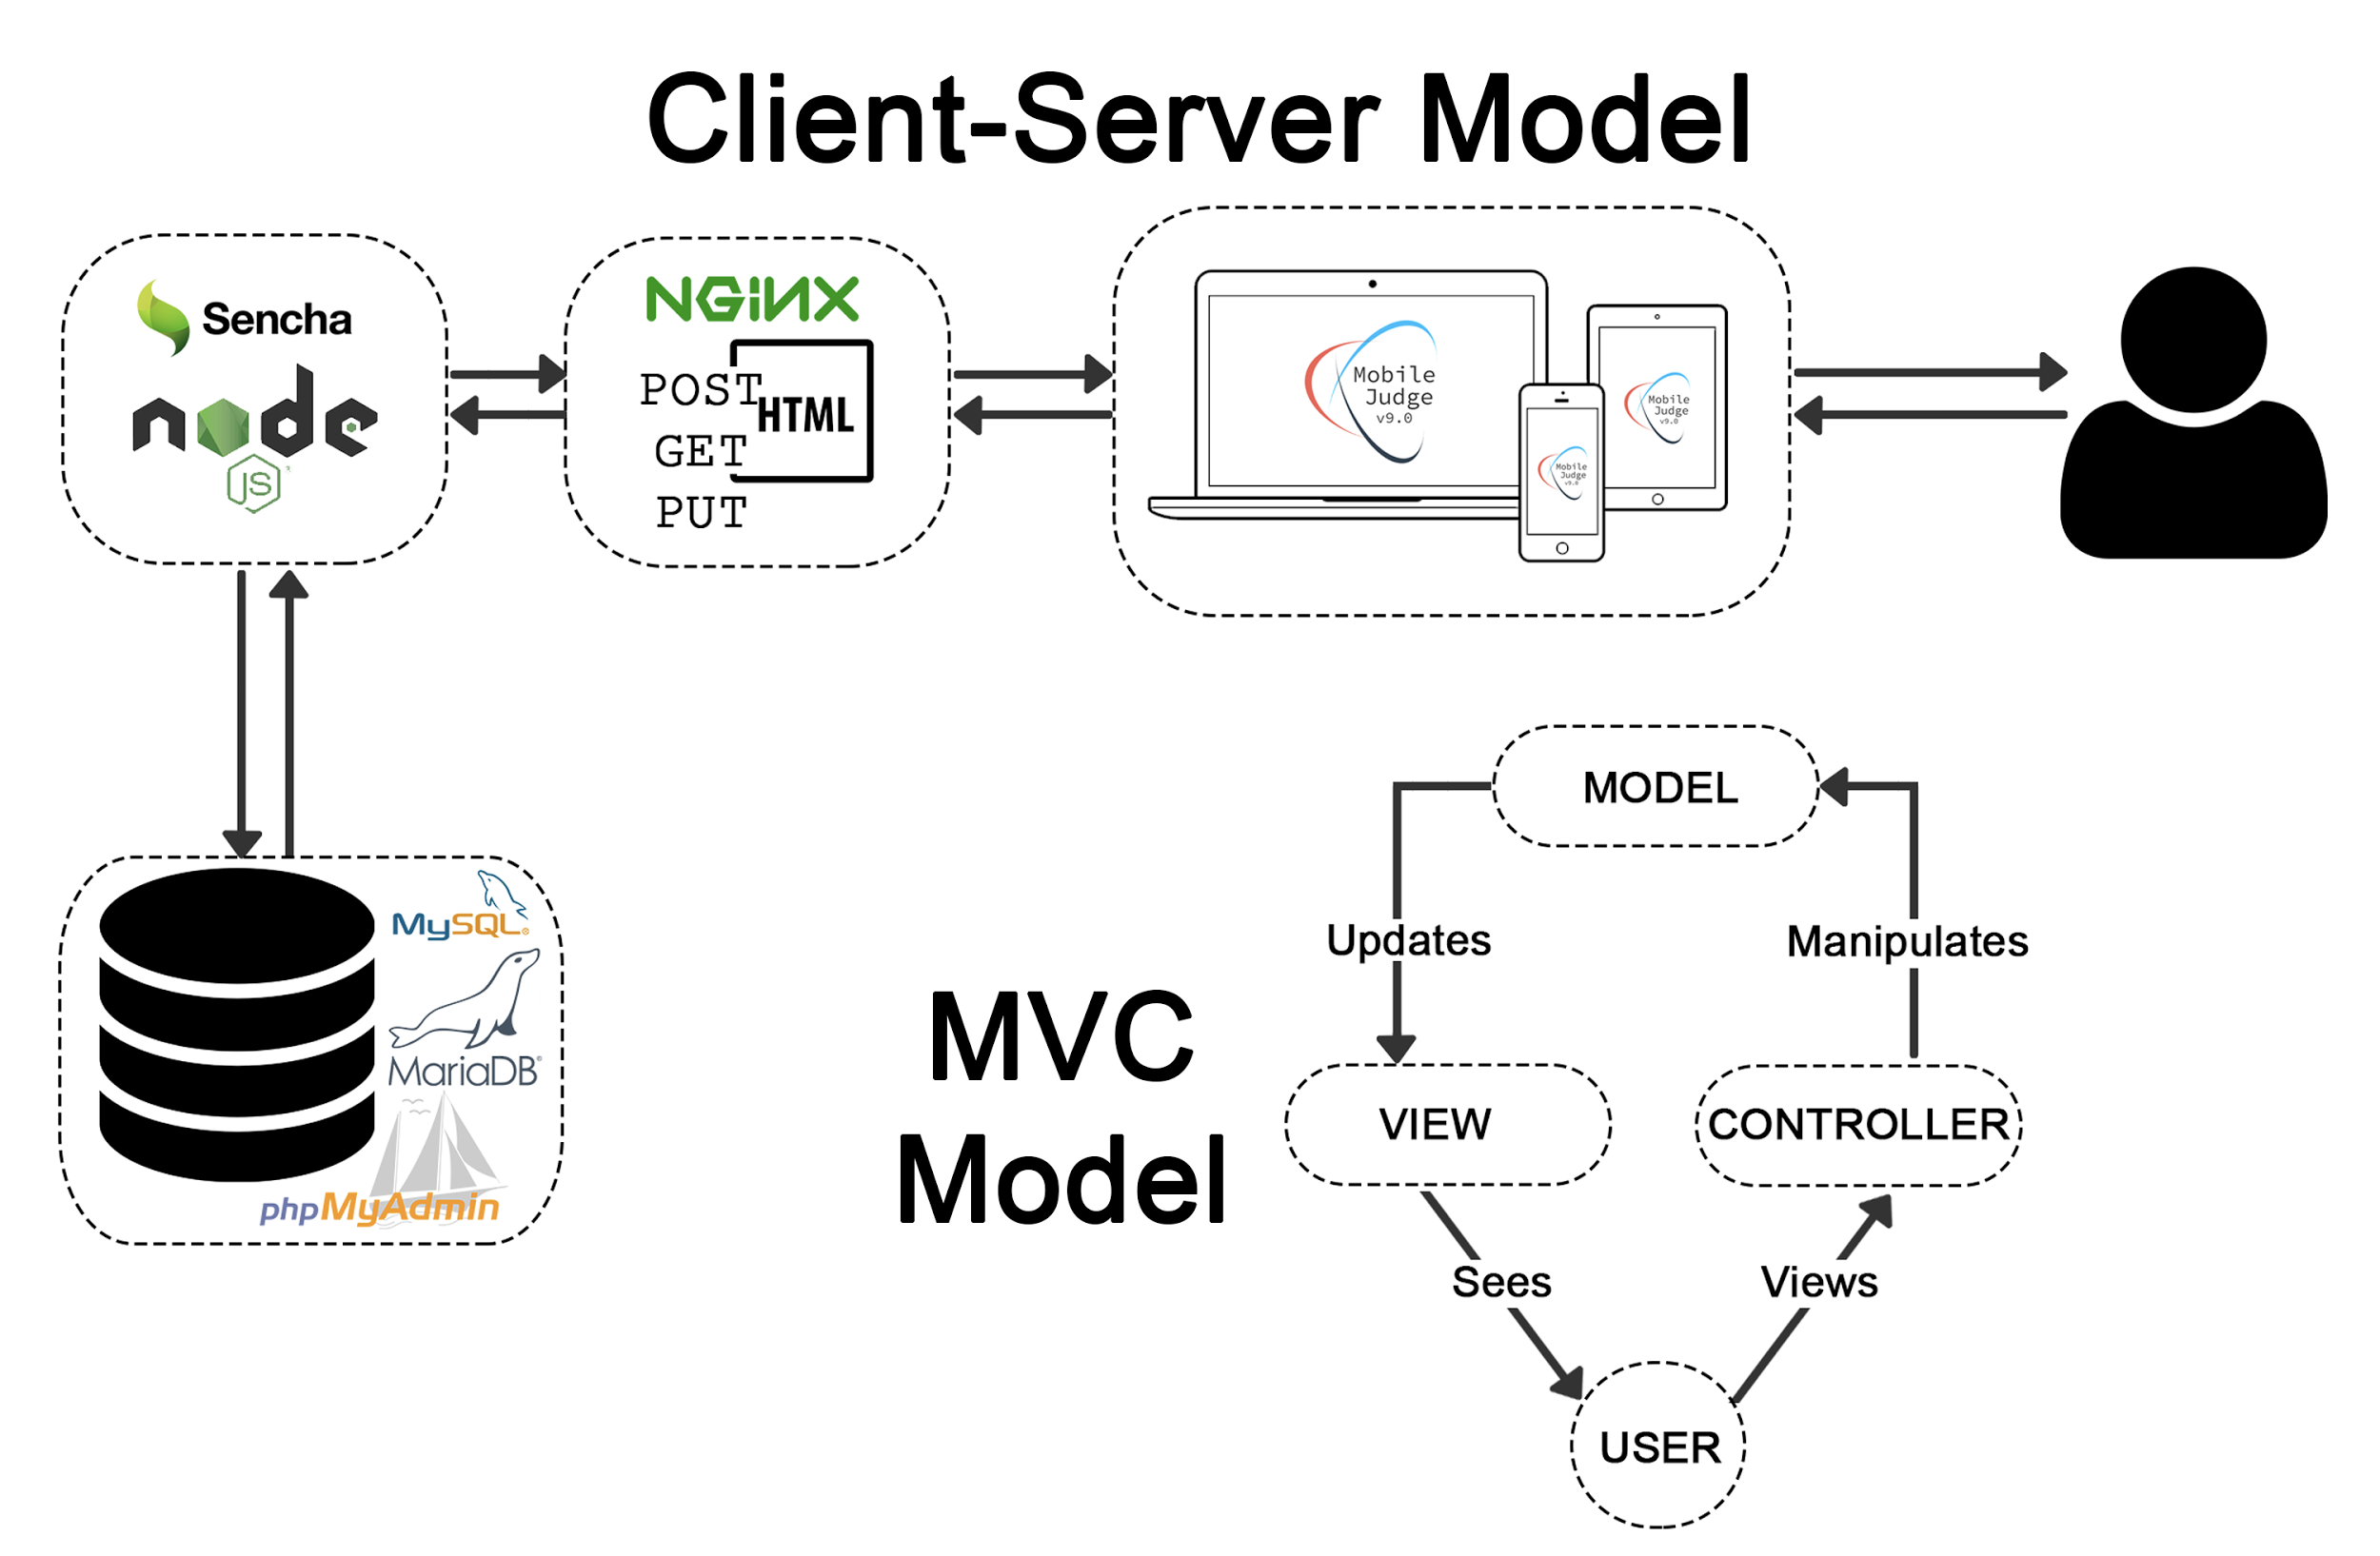

## System and Subsystem Decomposition

* **Views** - Contains all the views of the system and the content for the pages is rendered by Sencha. Different GUI elements on the pages trigger events.
* **Controllers** - Contains all the controllers of the system and represent the classes connecting the model and the view, and used to communicate between them.
* **Models** - Contains all the models of the system and represent the structure of the data and the methods to interact with the data store.

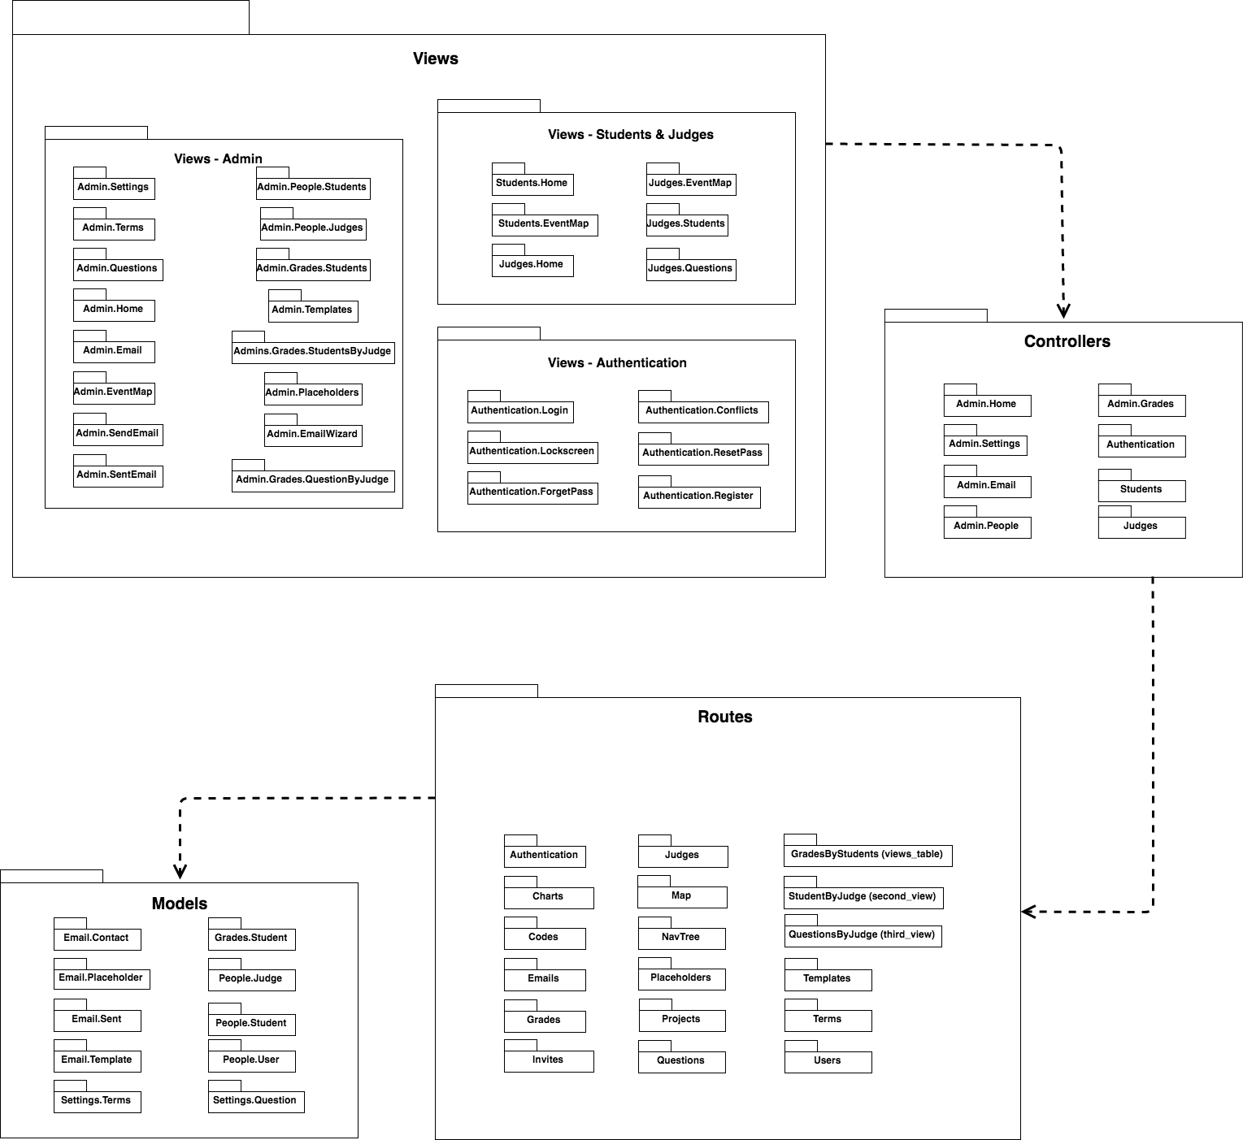

## Deployment Diagram

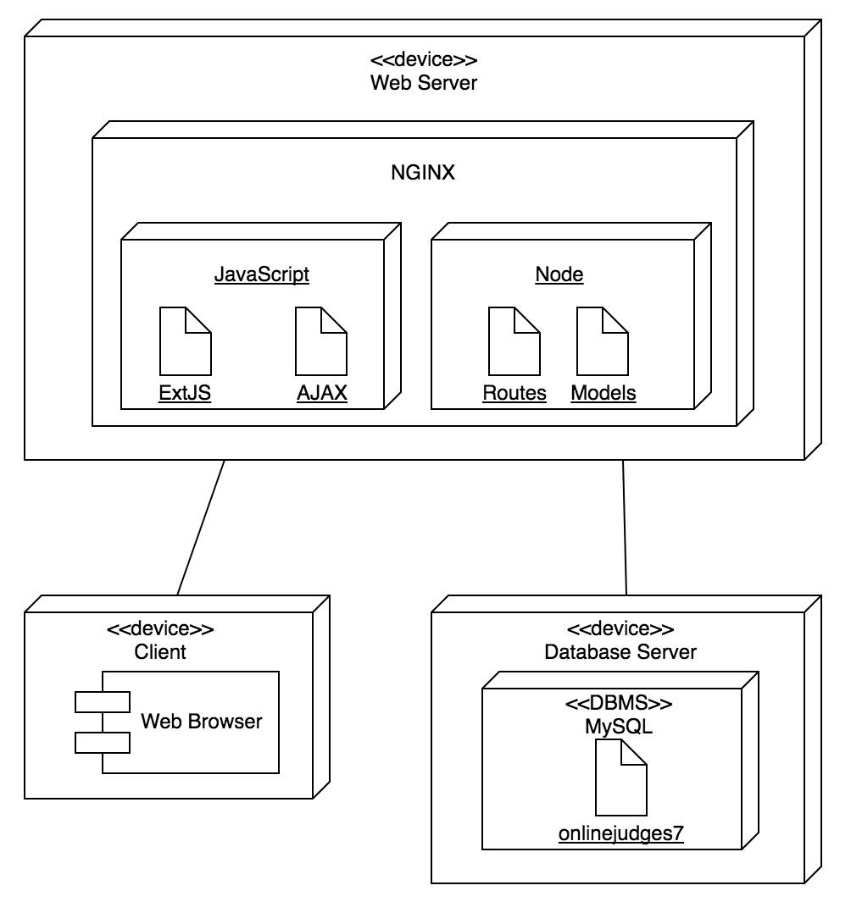

## Design Patterns

In Mobile Judge 10.0, there was no recognizable design patterns to create a reusable solution.

# System Validation

#694 - Accept Judge Invite

|  |
| --- |
| **Test case ID:** 694-01  **Description/Summary of Test:** As an invited judge that accepts invitation, be redirected to the placeholder page  **Pre-condition:** Clicks accepts on the invitation email  **Expected Results:** Redirected to a placeholder page with the showcase information  **Actual Result:** Redirected to a placeholder page with the showcase information  **Status (Fail/Pass):** Pass |

#703 - Change Terms on Mobile Settings

|  |
| --- |
| **Test case ID:** 703-01  **Description/Summary of Test:** Change to a different term and that the changes are seen on the site toolbar.  **Pre-condition:** Administrator is logged in and on the settings page, terms tab. Another existing semester must be in the database.  **Expected Results:** New term can be seen from dropdown menu and selected as well as being seen in the top toolbar.  **Actual Result:** New term can be seen from dropdown menu and selected as well as being seen in the top toolbar.  **Status (Fail/Pass):** Pass |

#704 - Change Terms on Mobile Settings

|  |
| --- |
| **Test case ID:** 704-01  **Description/Summary of Test:** Create a new Term and view it after.  **Pre-condition:** Administrator is logged in and on the settings page, terms tab. New term to be added does not exist in the system.  **Expected Results:** New term can be seen from dropdown menu and selected.  **Actual Result:** New term can be seen from dropdown menu and selected.  **Status (Fail/Pass):** Pass |

#705 - Delete Terms on Mobile Settings

|  |
| --- |
| **Test case ID:** 705-01  **Description/Summary of Test:** Delete a term.  **Pre-condition:** Administrator is logged in and on the settings page, terms tab. Term to be deleted must exist in the system.  **Expected Results:** Deleted term is not seen in the dropdown menu.  **Actual Result:** Deleted term is not seen in the dropdown menu.  **Status (Fail/Pass):** Pass |

#706 - Add Questions on Mobile Settings

|  |
| --- |
| **Test case ID:** 706-01  **Description/Summary of Test:** Create a new questions and see it being displayed in grid  **Pre-condition:** Administrator is logged in and on the settings page, terms tab. The question to be added does not exist in the system.  **Expected Results:** New question can be seen in the grid.  **Actual Result:** New question can be seen in the grid.  **Status (Fail/Pass):** Pass |

#708 - Delete Questions on Mobile Settings

|  |
| --- |
| **Test case ID:** 708-01  **Description/Summary of Test:** Delete a question and not seeing it in the grid.  **Pre-condition:** Administrator is logged in and on the settings page, terms tab. The question to be deleted already exists in the system.  **Expected Results:** New question cannot be seen in the grid.  **Actual Result:** New question cannot be seen in the grid.  **Status (Fail/Pass):** Pass |

#709 - Unregistered Judge User

|  |
| --- |
| **Test case ID**: 709-01  **Description/Summary of Test:** As an unregistered judge I want to be able to login into the website to finish my registration.  **Pre-condition:** Unregistered Judge accepted email invite  **Expected Results:** Unregistered Judge is able to Login into the website  **Actual Result:** Unregistered Judge is able to Login into the website  **Status (Fail/Pass):** Pass |

#710 - Unregistered Judge View

|  |
| --- |
| **Test case ID:** 710-01  **Description/Summary of Test:** As an unregistered judge that logged in to the website I want to be able to find myself in a list of all the pending judges.  **Precondition:** Unregistered Judge user is logged in.  **Expected Results:** Unregistered Judge is able to see all pending judges including itself.  **Actual Result:** Unregistered Judge is able to see all pending judges including itself.  **Status (Fail/Pass):** Pass |

#696 - New Registration Process

|  |
| --- |
| **Test case ID:** 696-01  **Description/Summary of Test:** A potential Judge, clicks on his/her name and is redirected to a registration page. Fill out form, clicks on done**.** It is redirected to Judge Home view and assigned students to judge.  **Pre-condition:** Unregistered Judge is logged in and Potential Judge clicks on his/her name  **Expected Results:** Redirected to Judge Home View and list of Students to grade appears  **Actual Result:** Redirected to Judge Home View and list of Students to grade appears  **Status (Fail/Pass):** Pass |

#693 Judge View By Students

|  |
| --- |
| **Test case ID:** 693-01  **Description/Summary of Test:** Log in as an Admin click on the Grades tab, then click on the Judges tab. Click on a Judge and then a Student.  **Pre-condition:** Must be an admin and must have judges and students already assigned to each other.  **Expected Results:** When clicking on the judge tab a popup should appear with a populated list of students that the judge was assigned to and when clicking on the student the popup should change to the student’s questions and the grades.  **Actual Result:** Clicking on a judge shows a popup that has a list of students that correctly belong to the judge and clicking on a student in the popup shows a list of the questions that the judge graded.  **Status (Fail/Pass):** Pass |

#699 Fix DB Update

|  |
| --- |
| **Test case ID:** 699-01  **Description/Summary of Test:** Log in as an Admin and view the Grades Tab.  **Pre-condition:** Students that have already taken VIP Juniors are present in the Database and are currently enrolled this semester.  **Expected Results:** When checking the previous semester the Grades for those students are properly available and then when checking the current semester everything is blank.  **Actual Result:** Everything is blank in the current semester and the previous semester had everything recorded properly.  **Status (Fail/Pass):** Pass |

#702 Fix Stop Light Issues

|  |
| --- |
| **Test case ID:** 702-01  **Description/Summary of Test:**  Log in as an Admin click on the Grades tab, then click on the Judges tab. Click on a Judge and then a Student Stoplight.  **Pre-condition:** Must be an admin and must have judges and students already assigned to each other.  **Expected Results:** When clicking on the judge tab a popup should appear with a populated list of students that the judge was assigned to and when clicking on the student stoplight the light should change to the next color (if green -> red, if red -> yellow, if yellow-> green).  **Actual Result:** Clicking on a judge shows a popup that has a list of students that correctly belong to the judge and clicking on a student stoplight appropriately changes the status while simultaneously updating the image of the stoplight  **Status (Fail/Pass):** Pass |

|  |
| --- |
| **Test case ID:** 702-02  **Description/Summary of Test:** Log in as an Admin click on the Grades tab, then click on the Judges tab. Click on a Judge and then the Global Stoplight.  **Pre-condition:** Must be an admin and must have judges and students already assigned to each other.  **Expected Results:** When clicking on the judge tab a popup should appear with a populated list of students that the judge was assigned to and when clicking on the global stoplight, a menu should appear that allows you to change the status of all the students in the list. Once choosing a status, the global stop light should change to the appropriate color as well as the students in the list. Also the stoplight in the judges tab should also change according to all the statuses of the students in the list. (accepted -> green, pending -> yellow, rejected -> red). Multiple lights should be on if multiple statuses are in the list.  **Actual Result:** Clicking on a judge shows a popup that has a list of students that correctly belong to the judge and clicking on a student stoplight appropriately changes the status while simultaneously updating the image of the stoplight in all of the proper locations.  **Status (Fail/Pass):** Pass |

# 

# 

# 

# Appendix

## Appendix A - UML Diagrams

**Use Case Diagram**

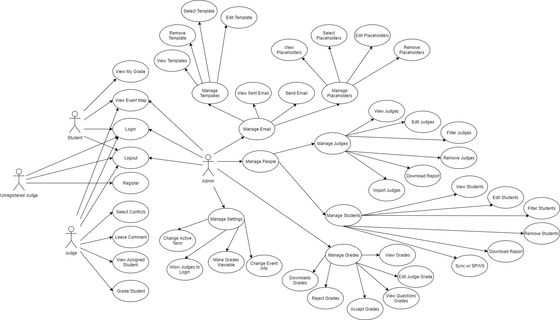

**Minimal Class Diagram**

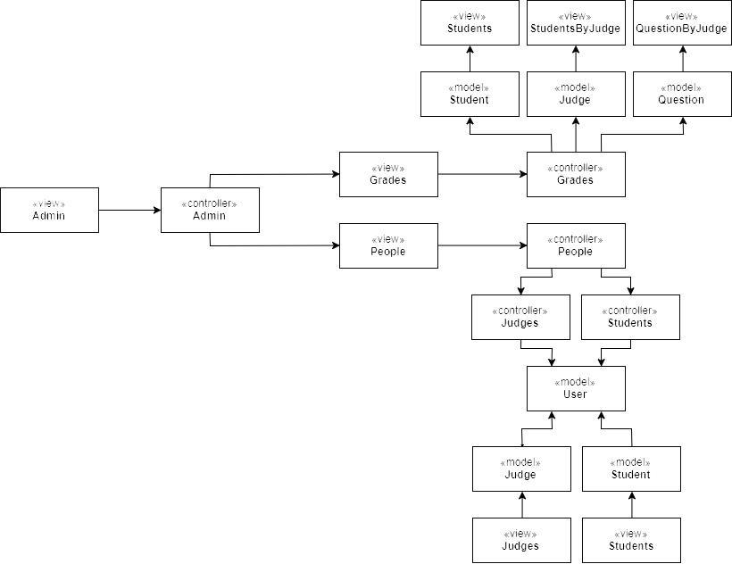

**UML Diagrams - Static & Dynamic Diagrams**

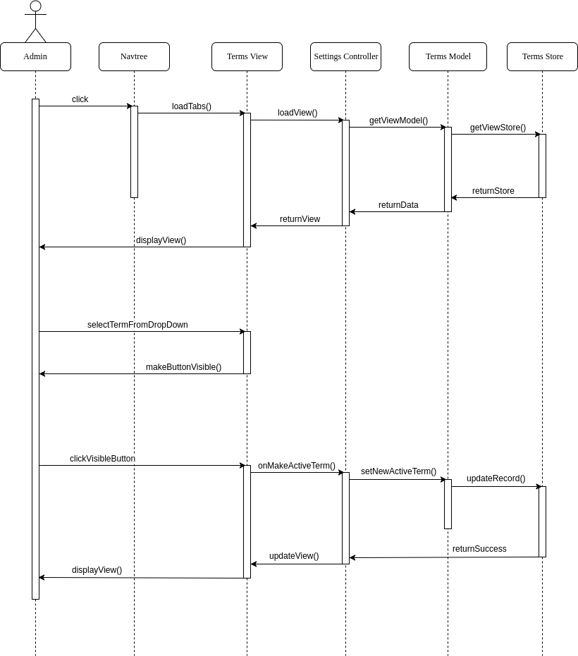

Change Terms on Mobile Sequence

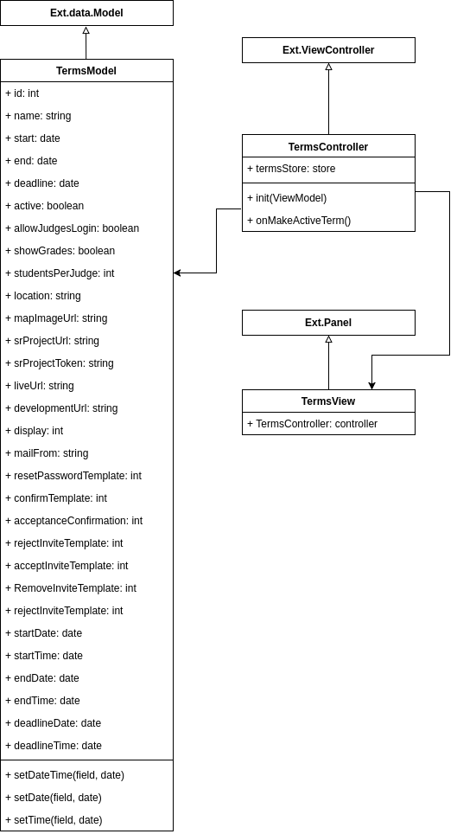

Change Terms on Mobile Settings Class Diagram

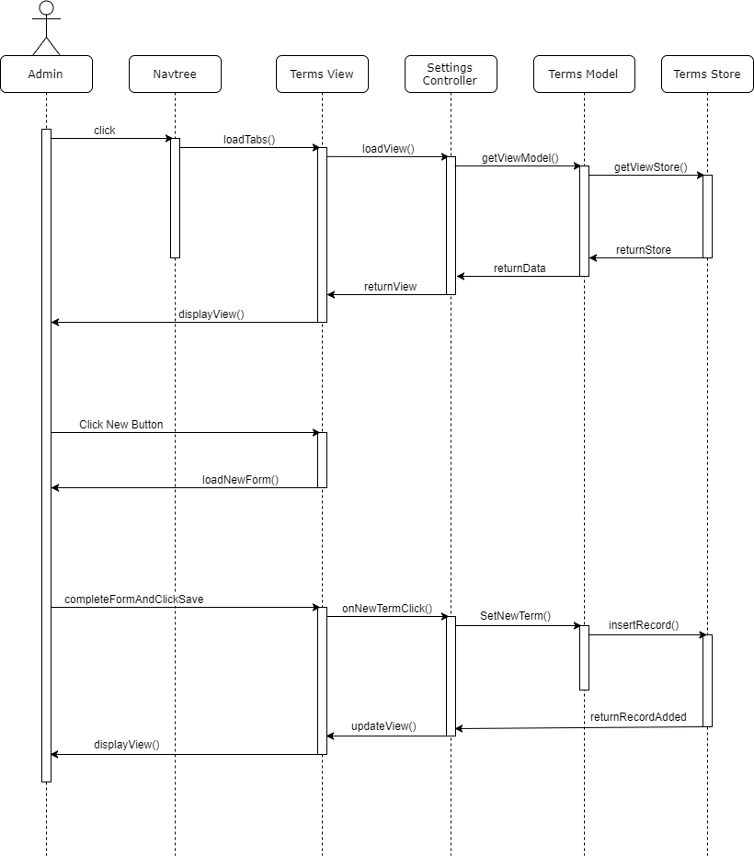

Create Terms on Mobile Settings Sequence

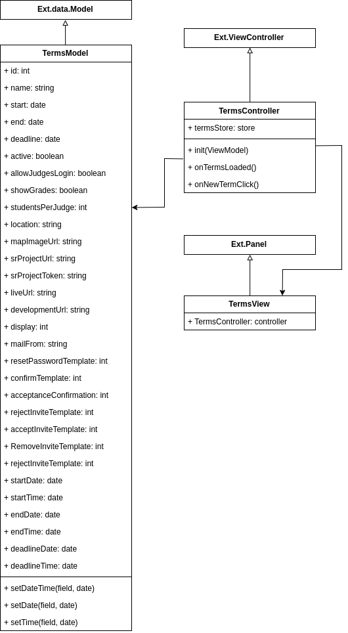

Create Terms on Mobile Settings Class Diagram

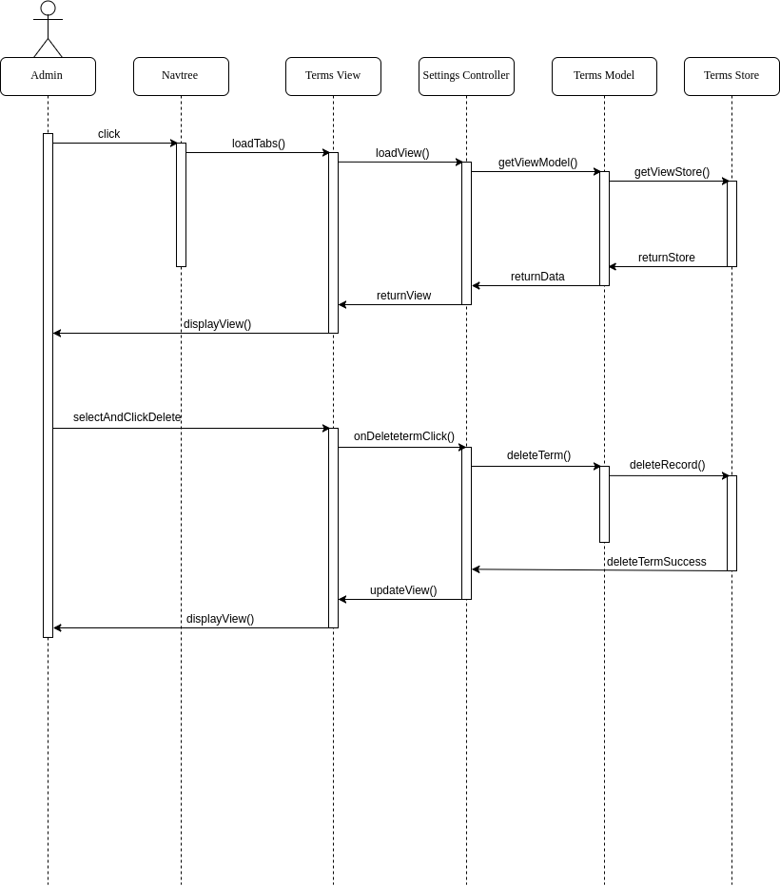

Delete Terms on Mobile Settings Sequence

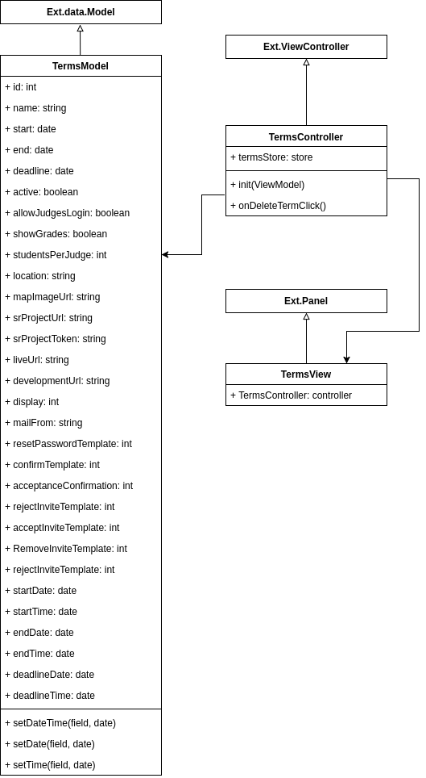

Delete Terms on Mobile Settings Class Diagram

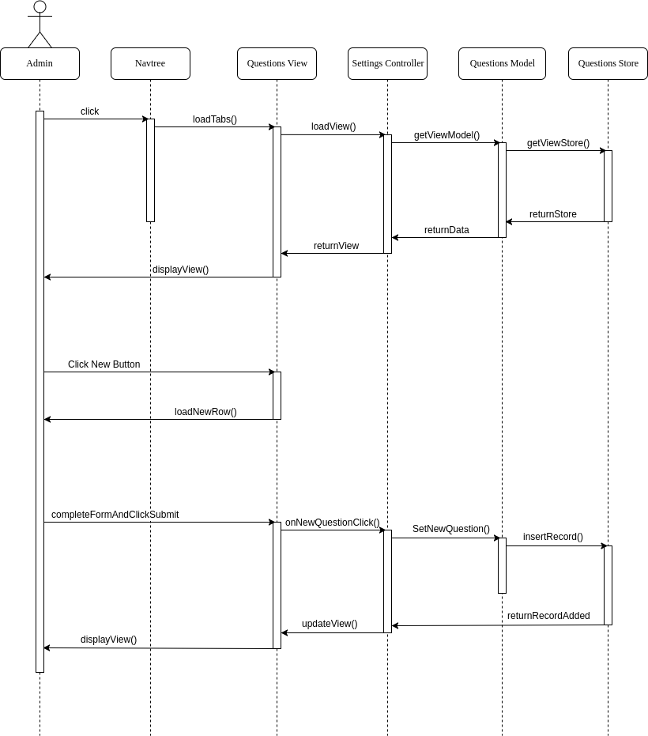

Add Questions on Mobile Settings

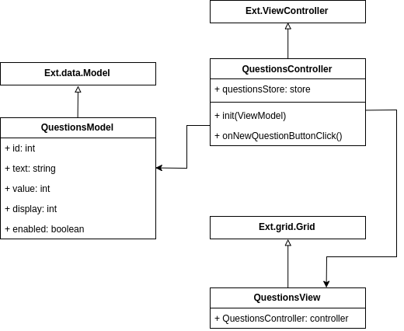

Add Questions on Mobile Settings Class Diagram

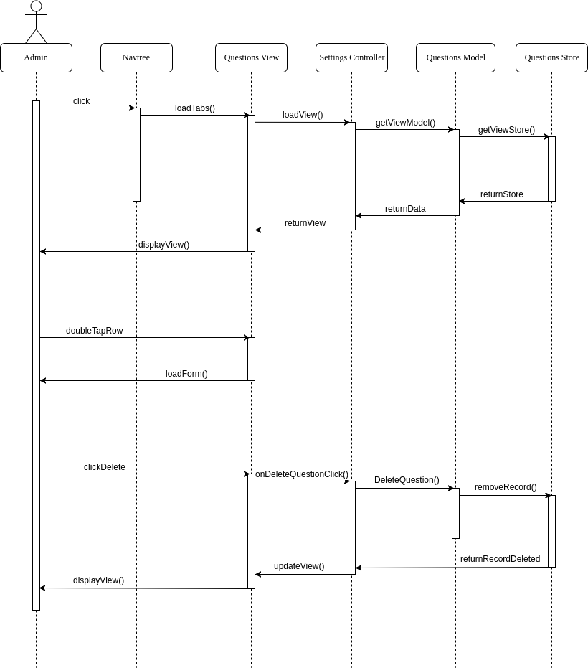

Delete Questions on Mobile Settings Sequence



Delete Questions on Mobile Settings Class Diagram

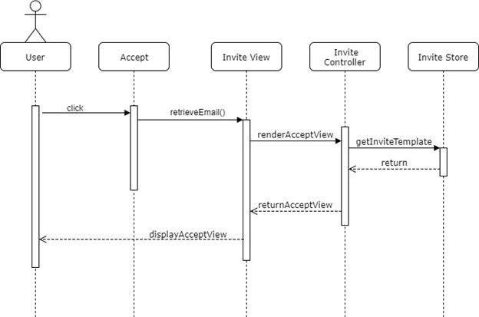

View Accept Invitation Page Sequence

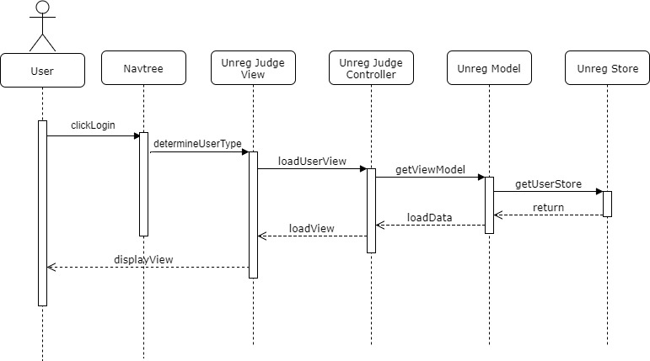

Unregistered Judge User Sequence Diagram

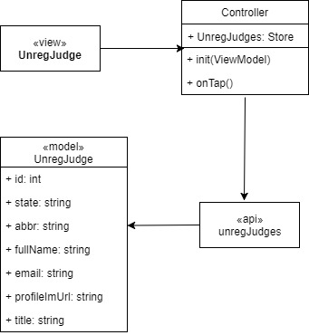

Unregistered Judge User Class Diagram

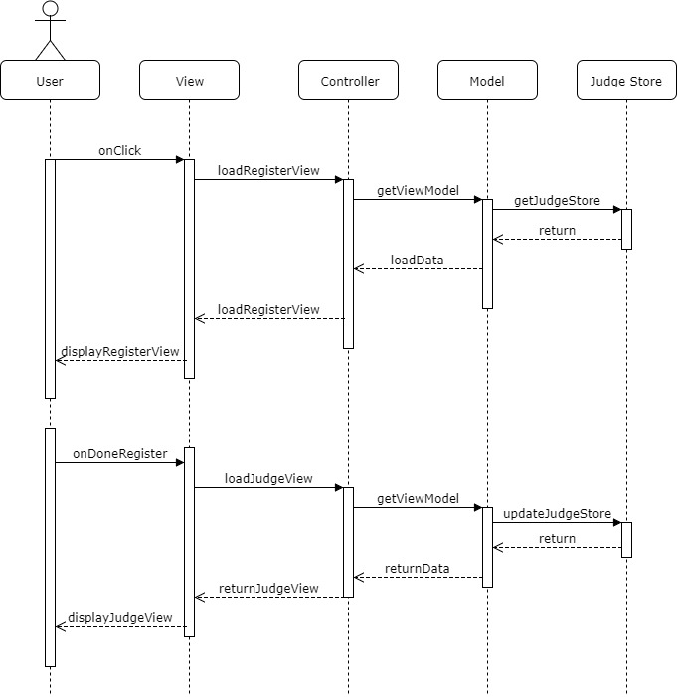

New Registration Process Sequence Diagram

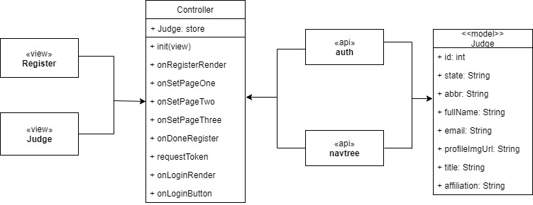

New Registration Process Class Diagram

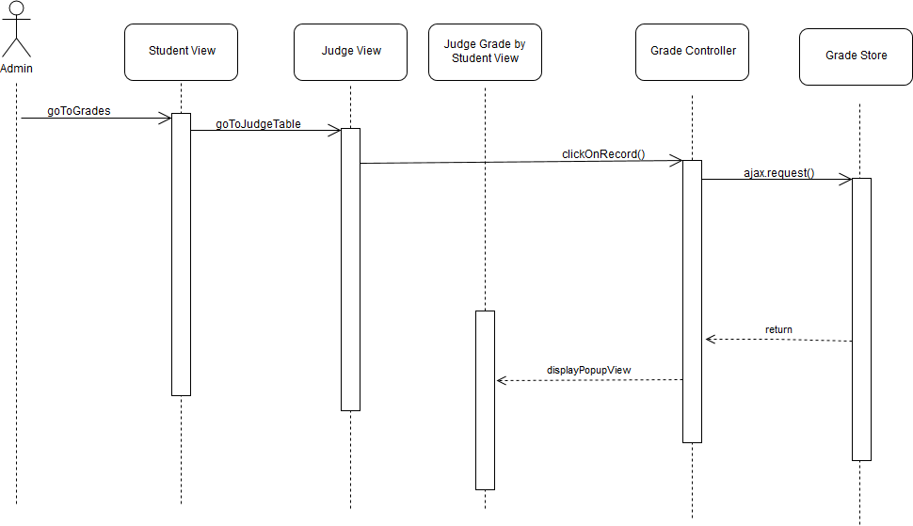

Judge View By Students Sequence Diagram (Second View)

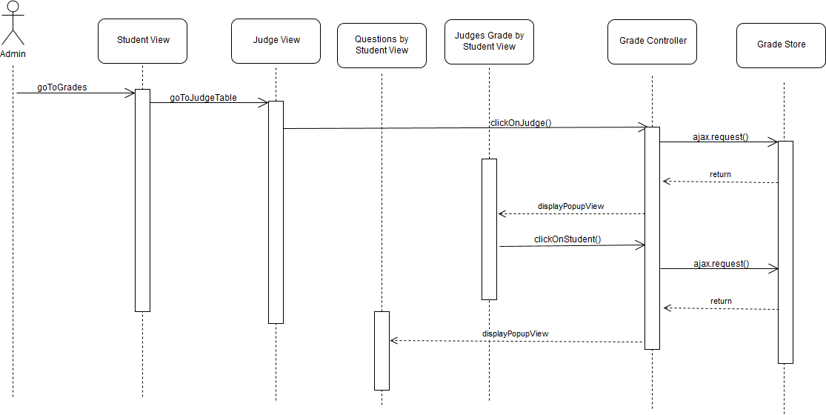

Judge View By Students Sequence Diagram (Third View)

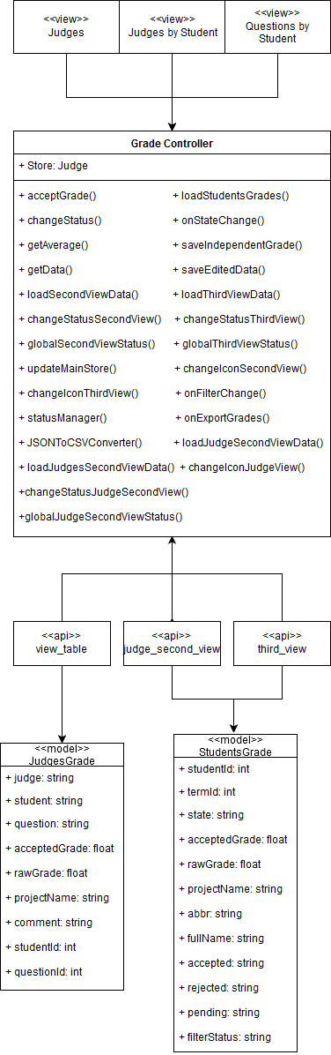 (Judge View By Students Class Diagram)

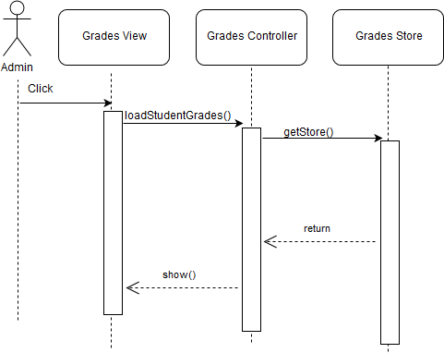

Database for Grades Update Sequence Diagram

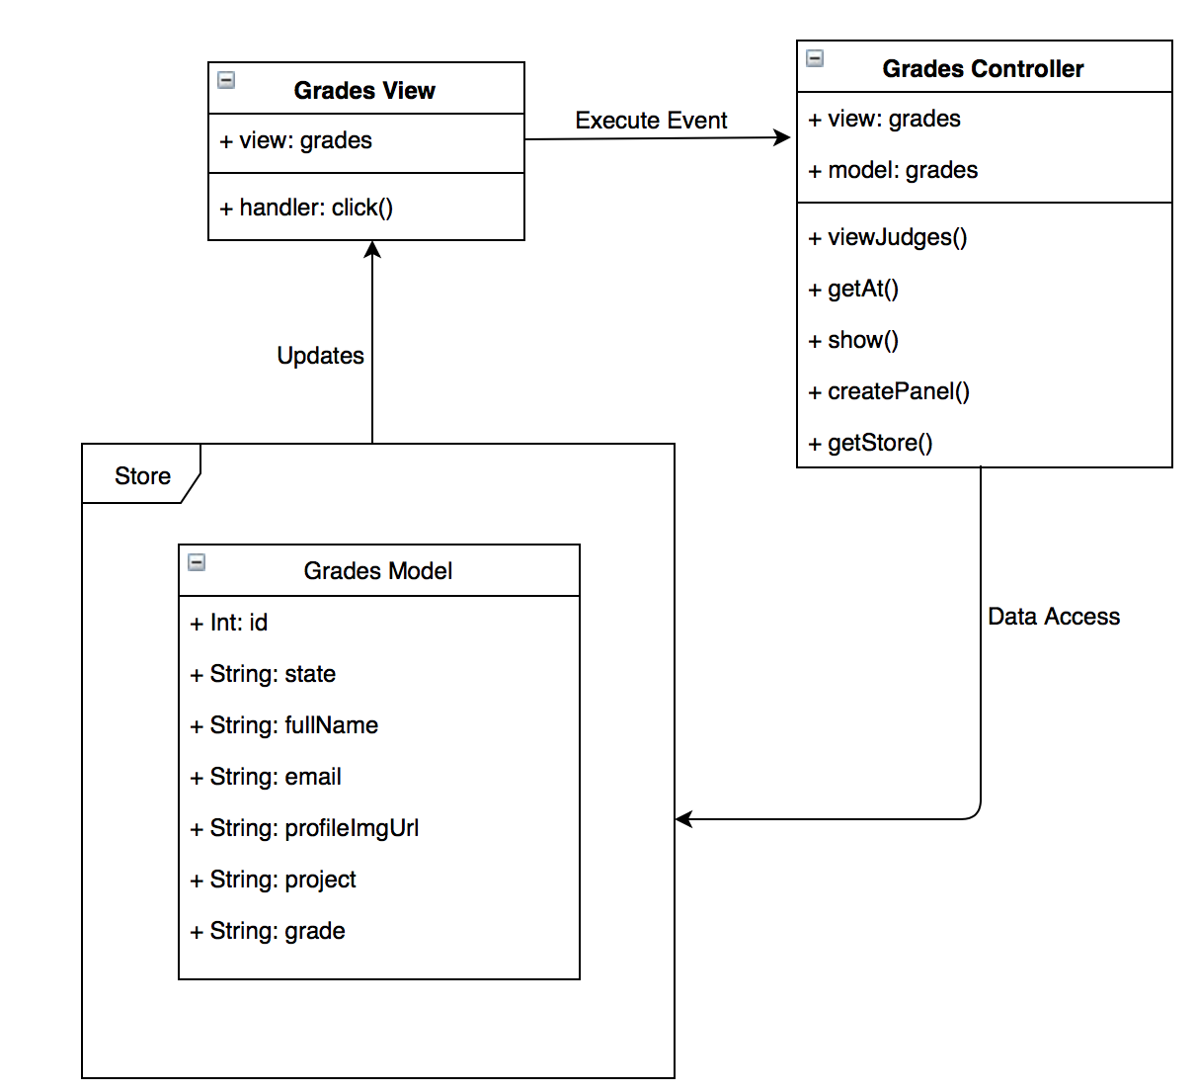

Class Diagram for DB and Grades

## Appendix B - User Interface Design

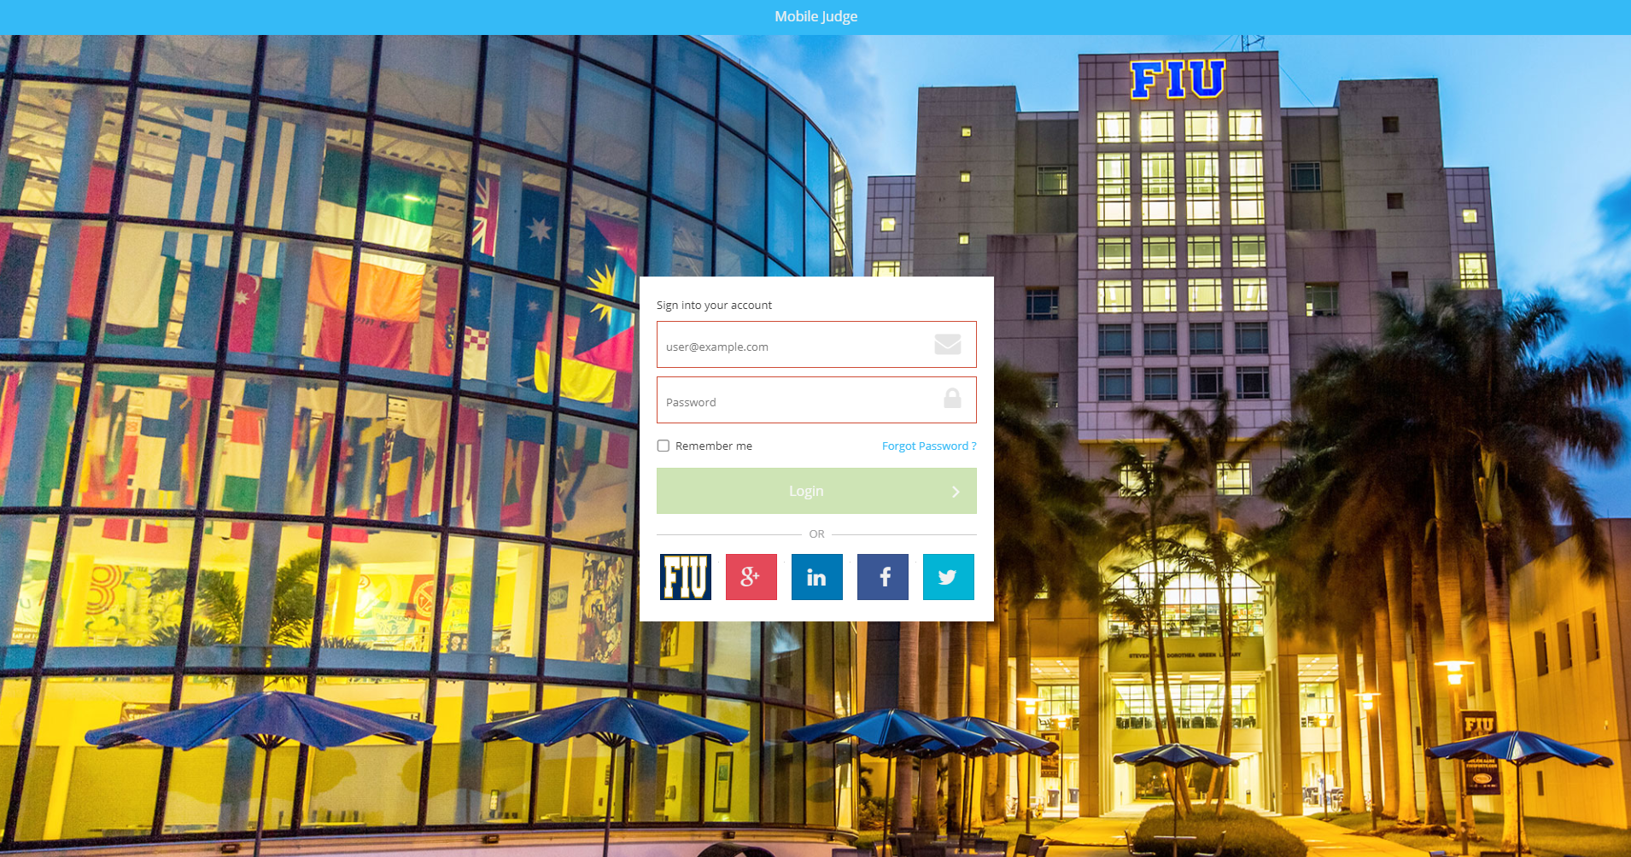

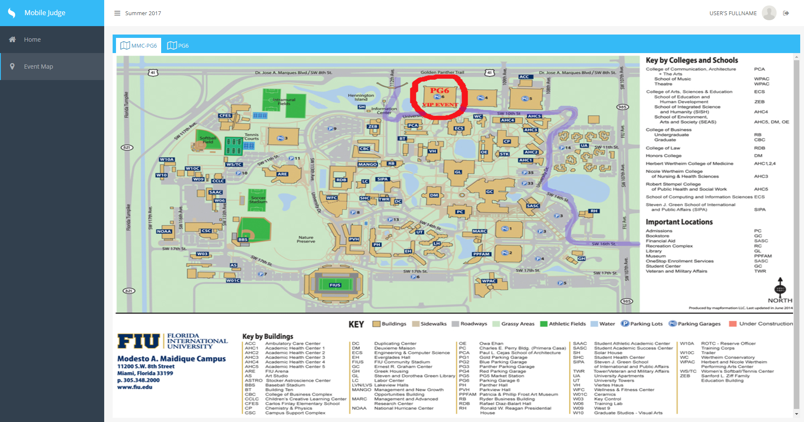

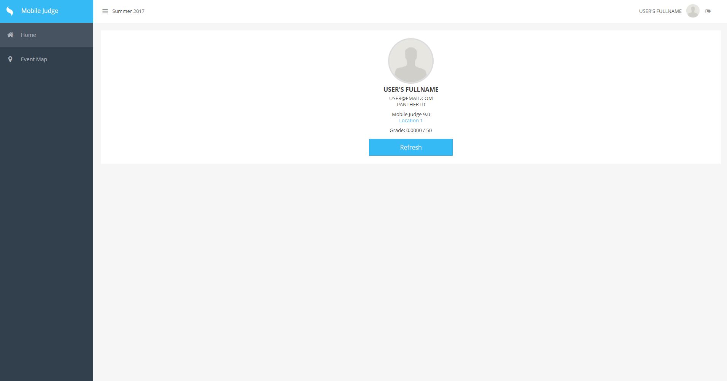

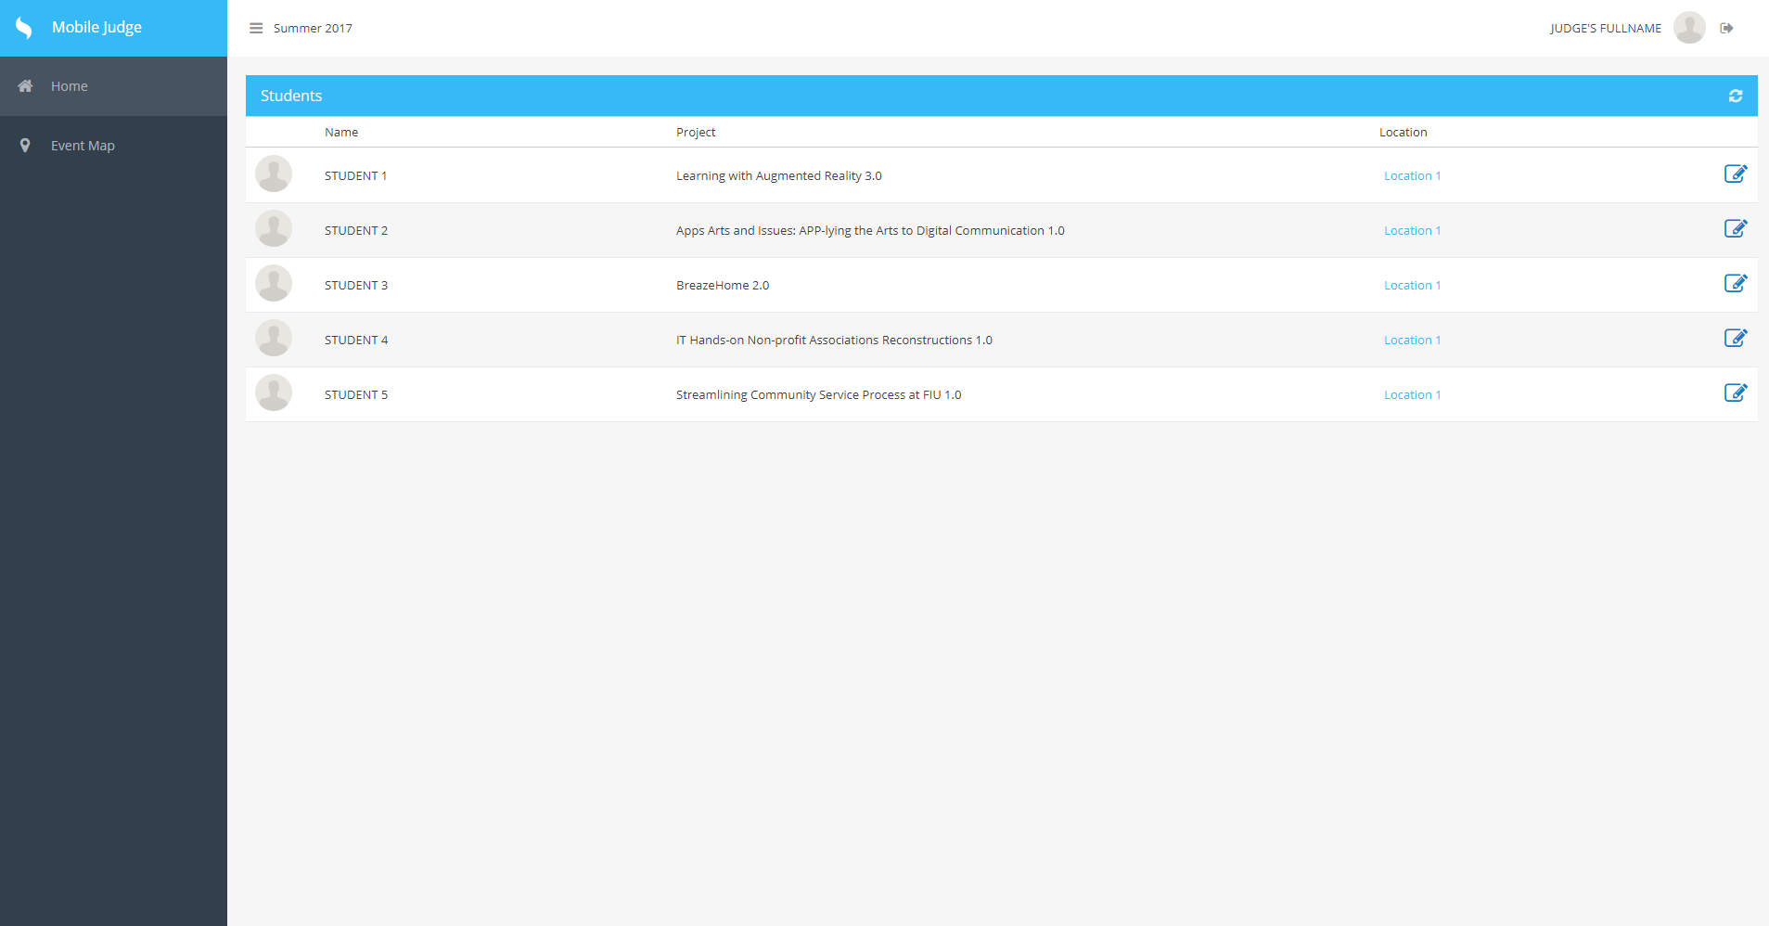

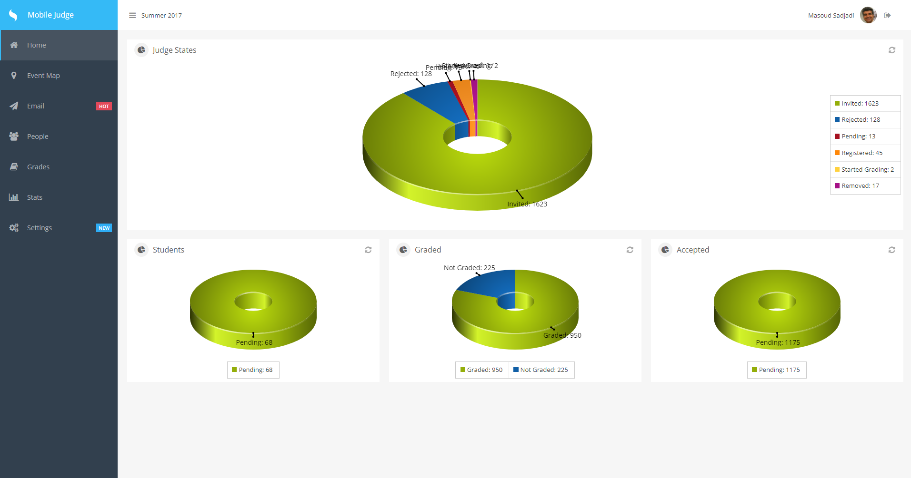

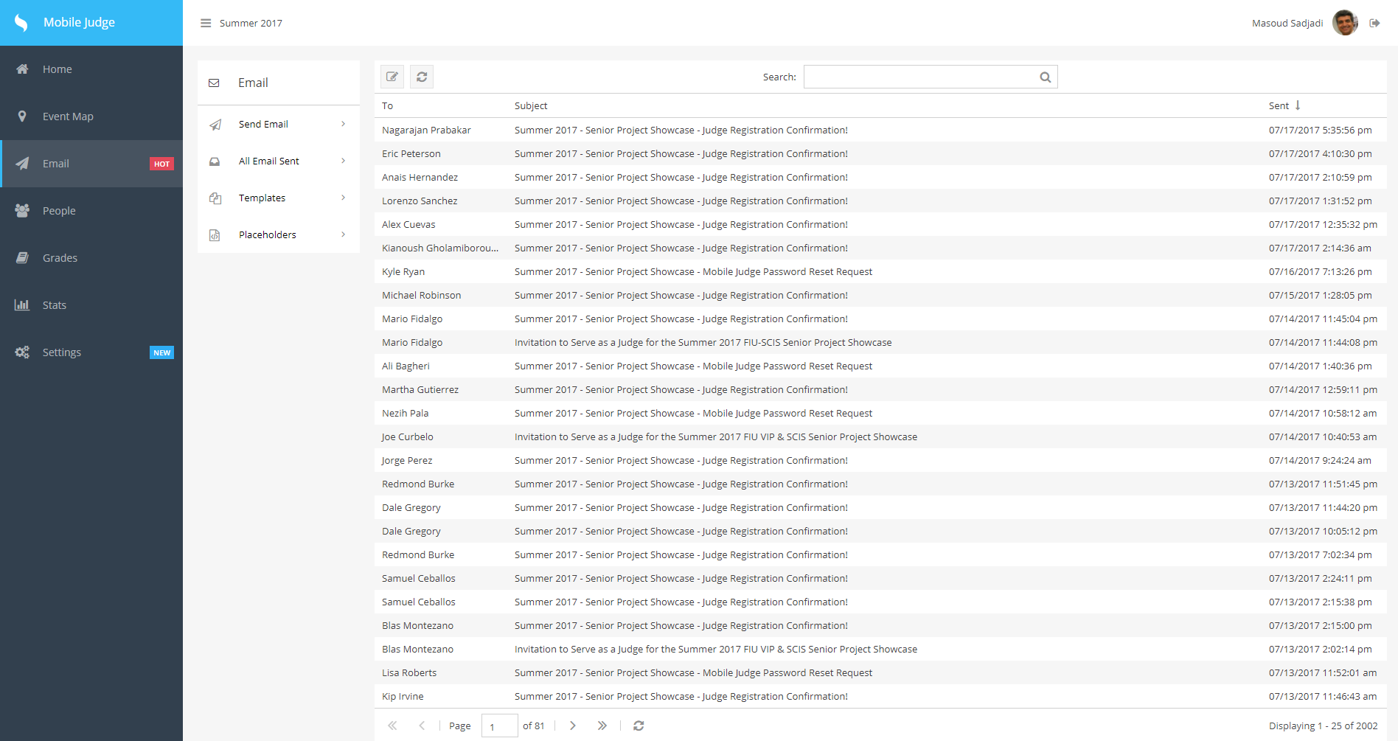

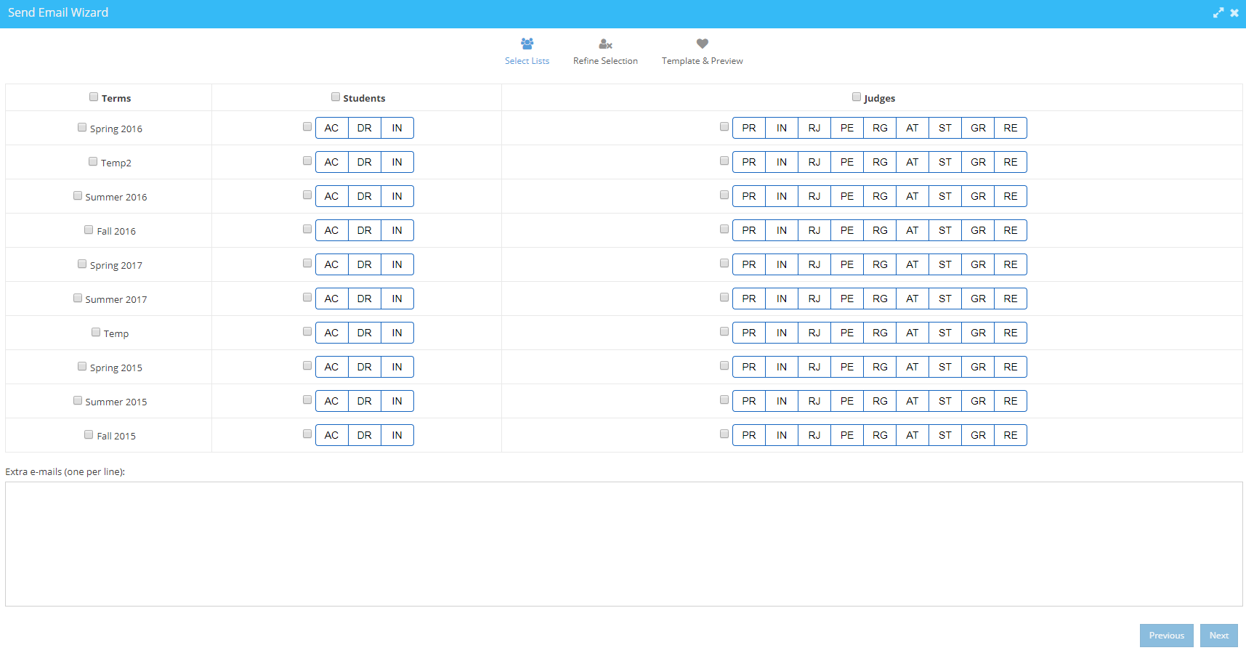

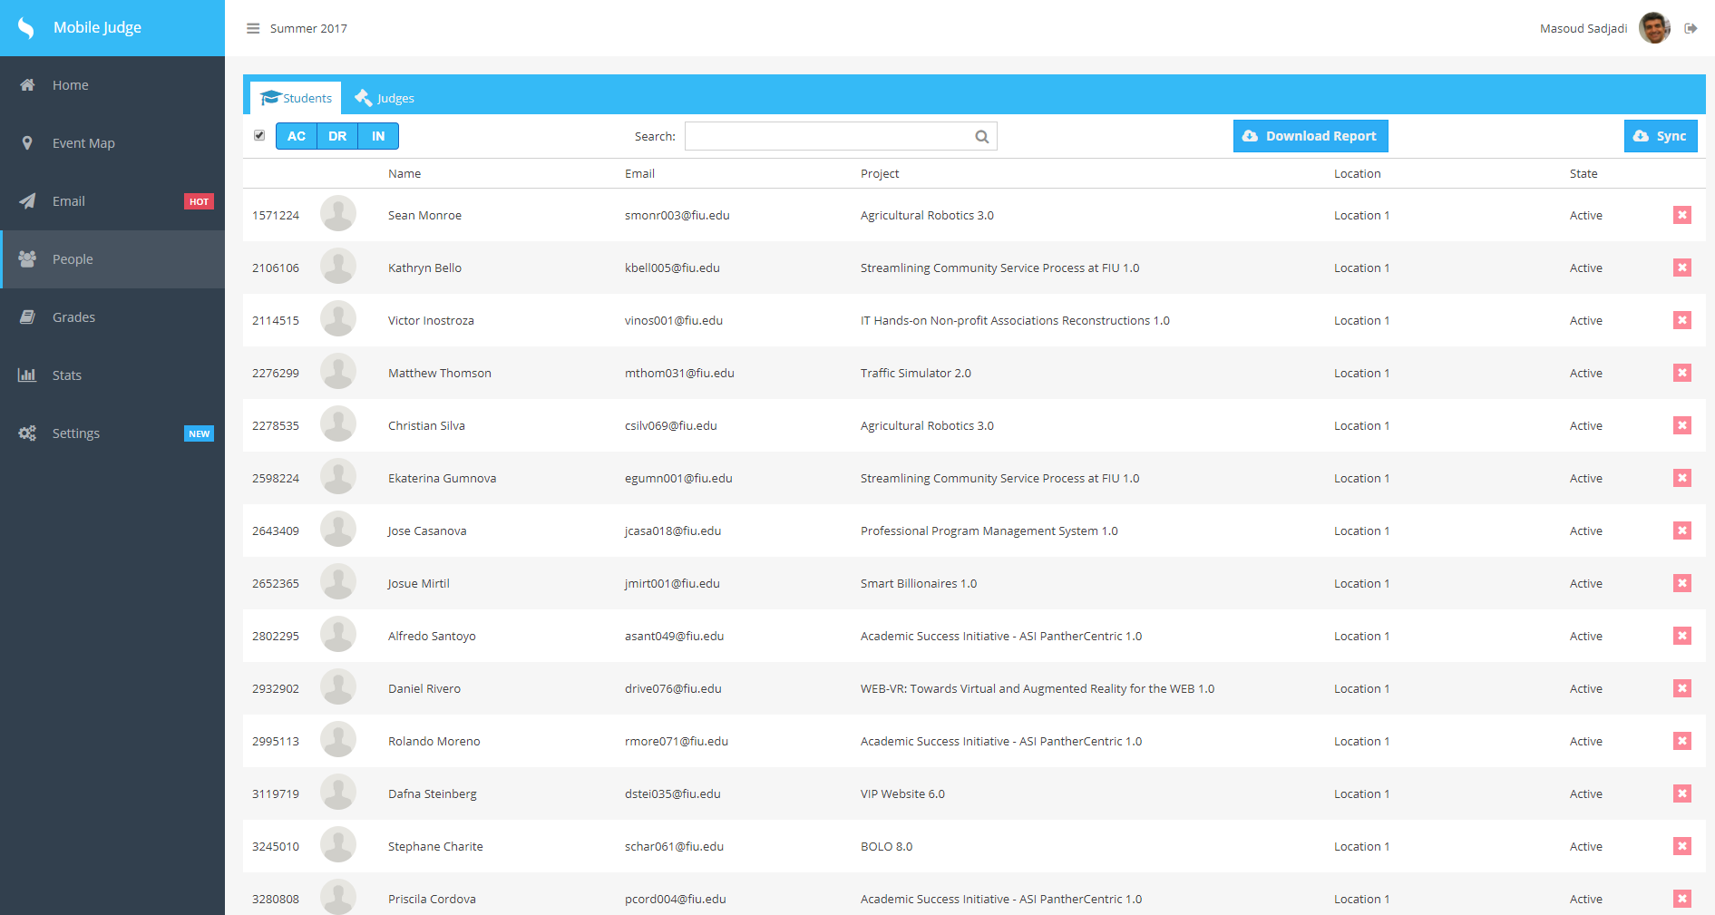

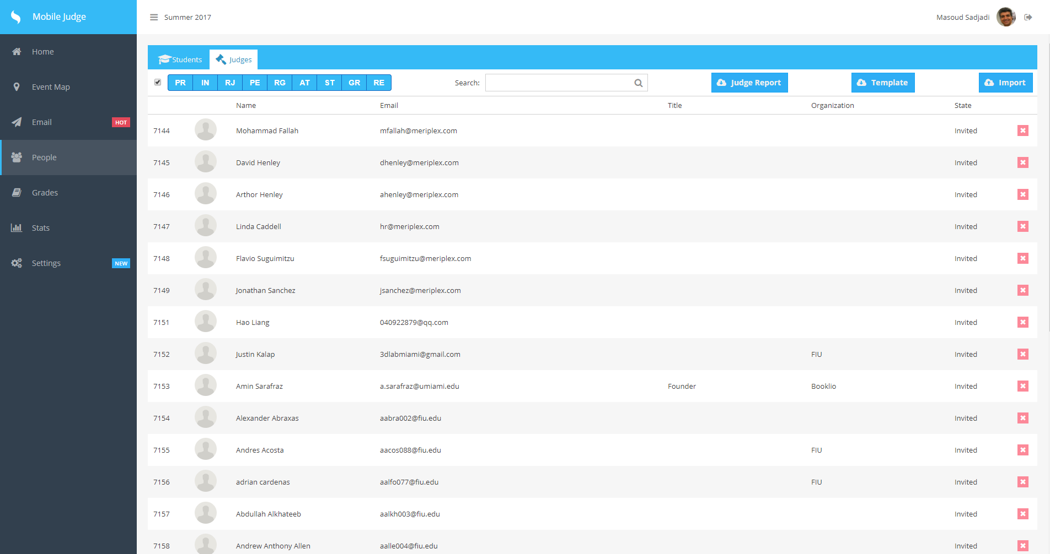

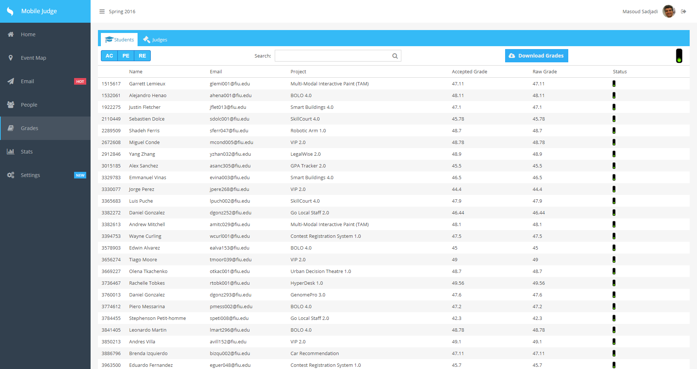

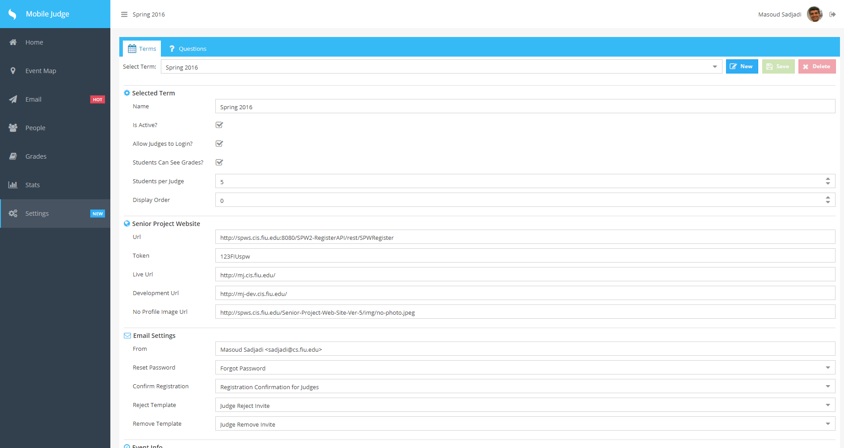

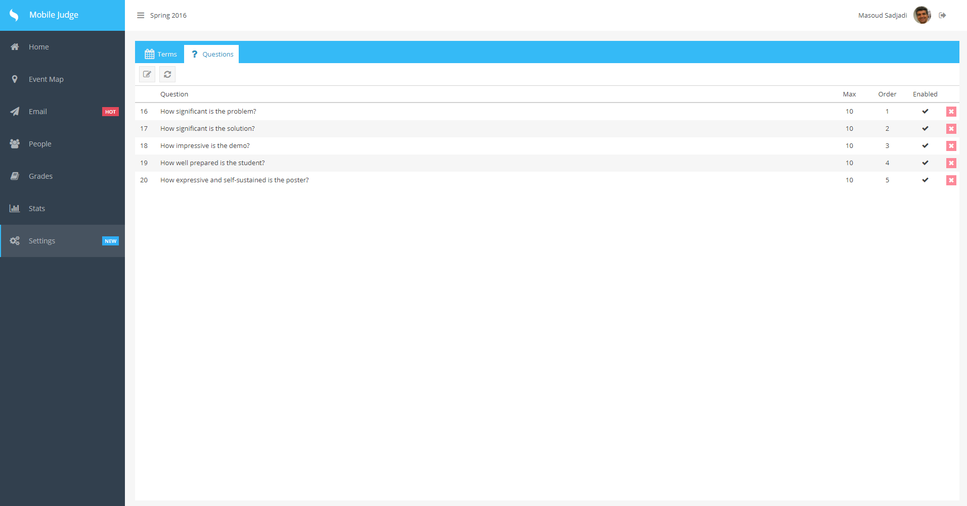

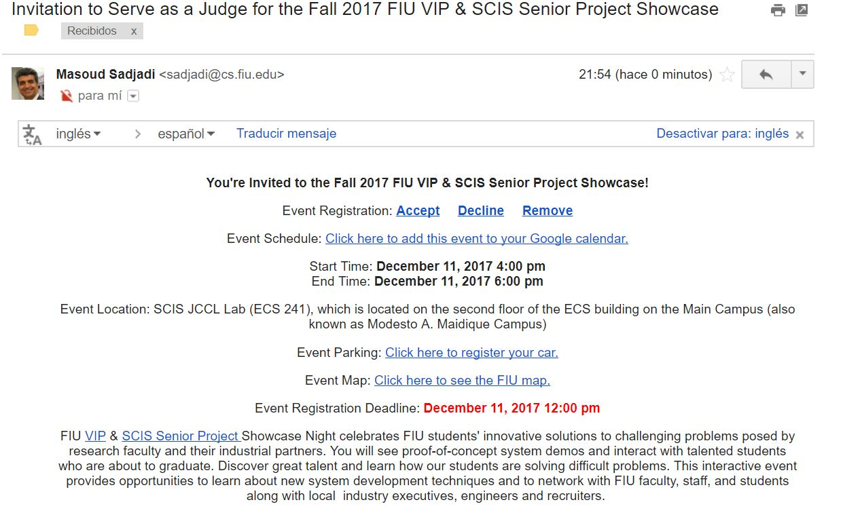

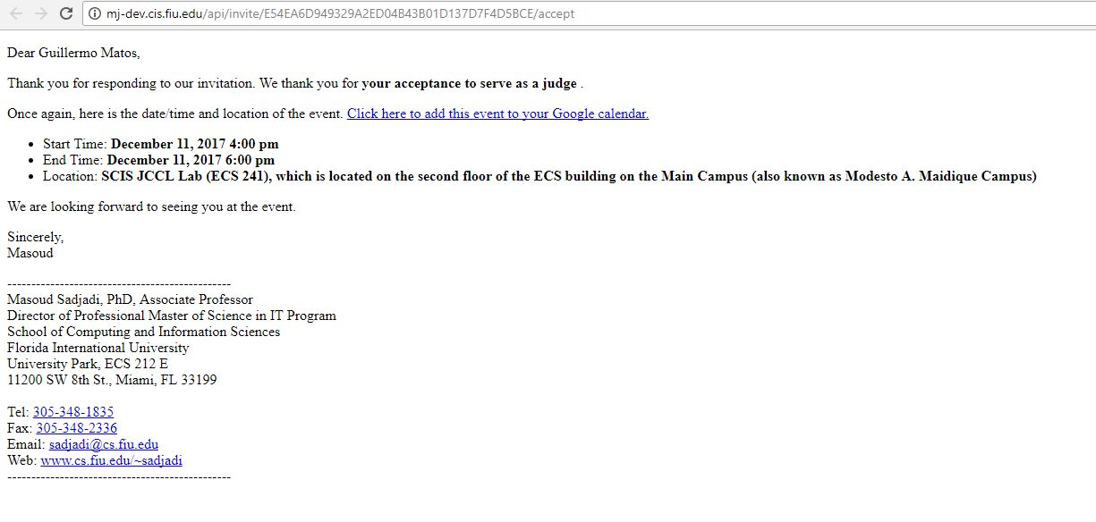

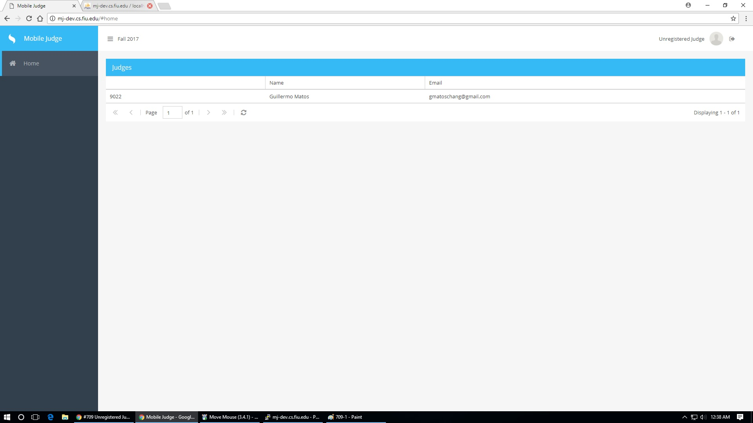

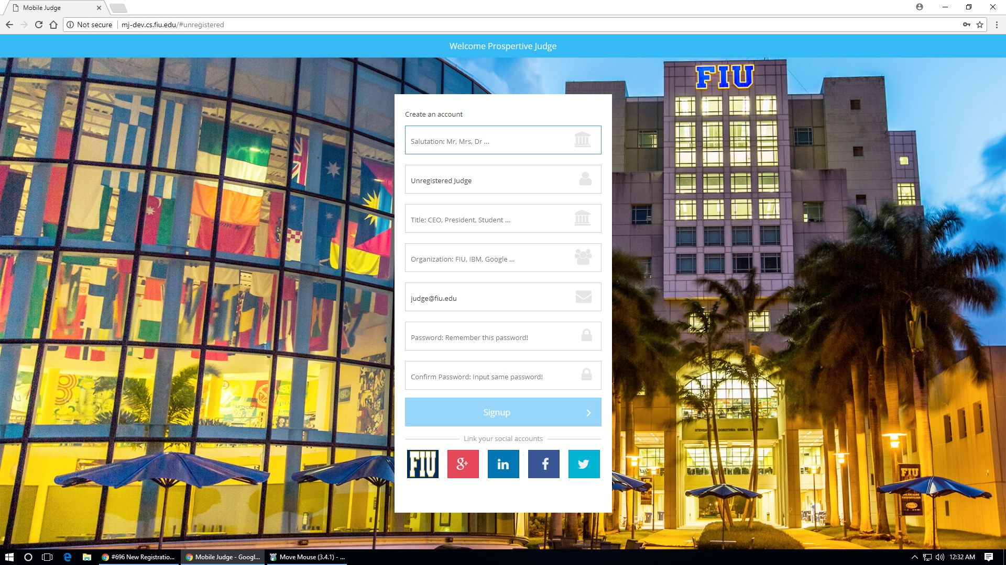

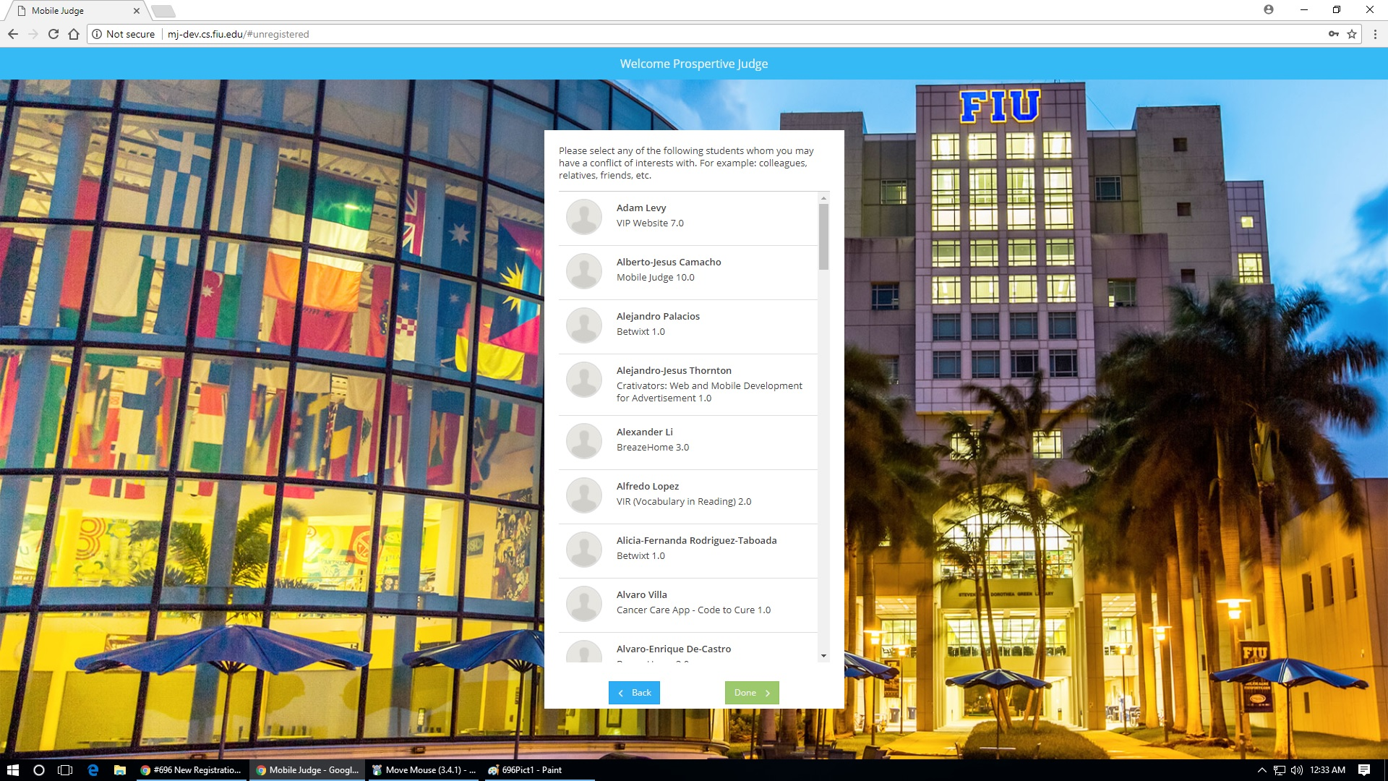

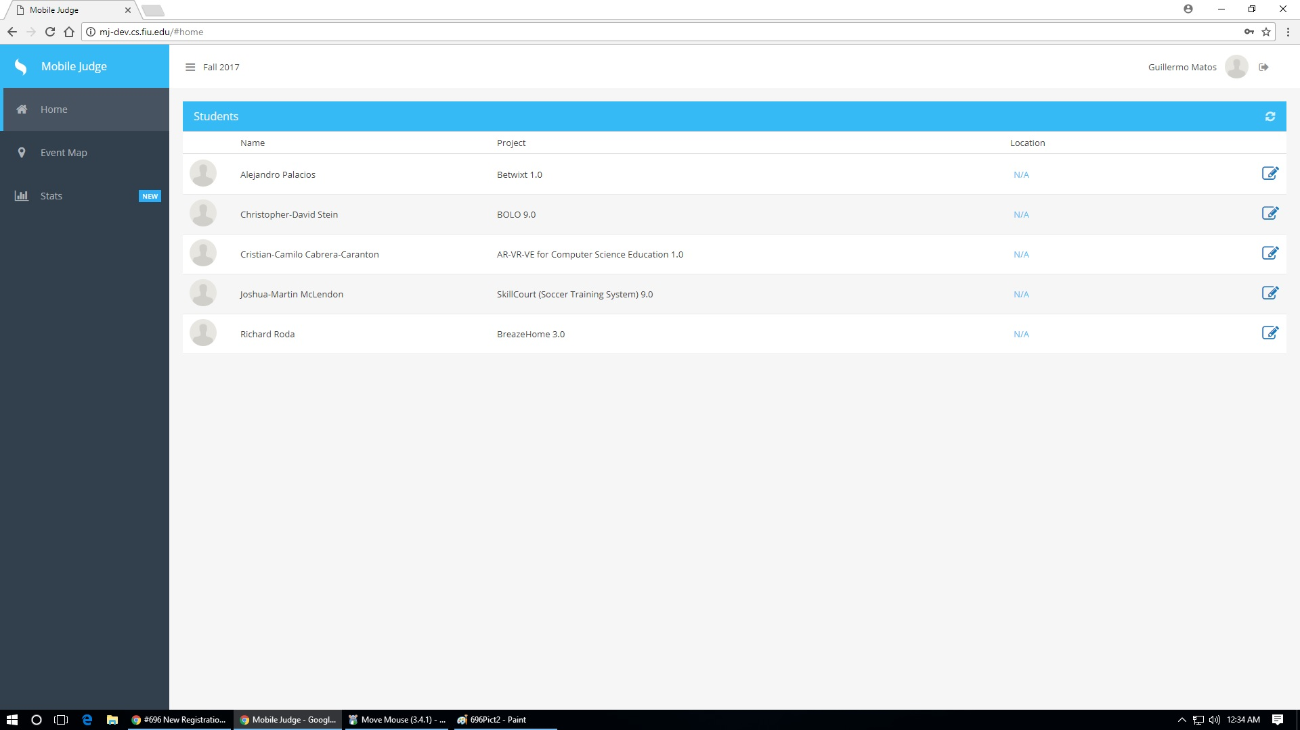

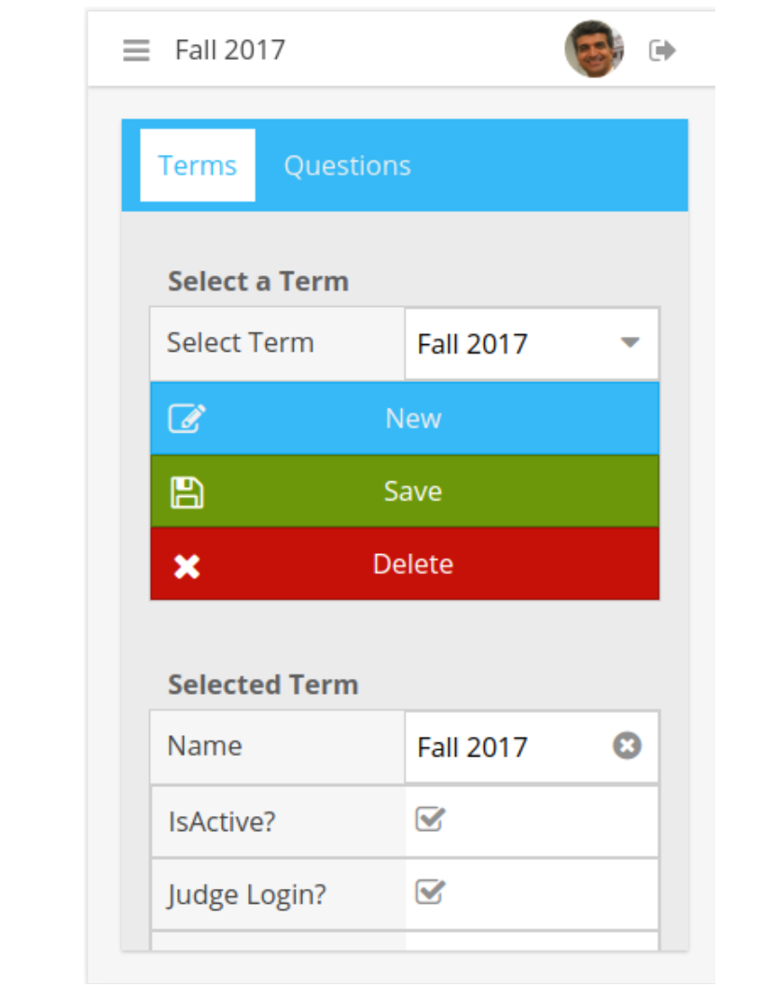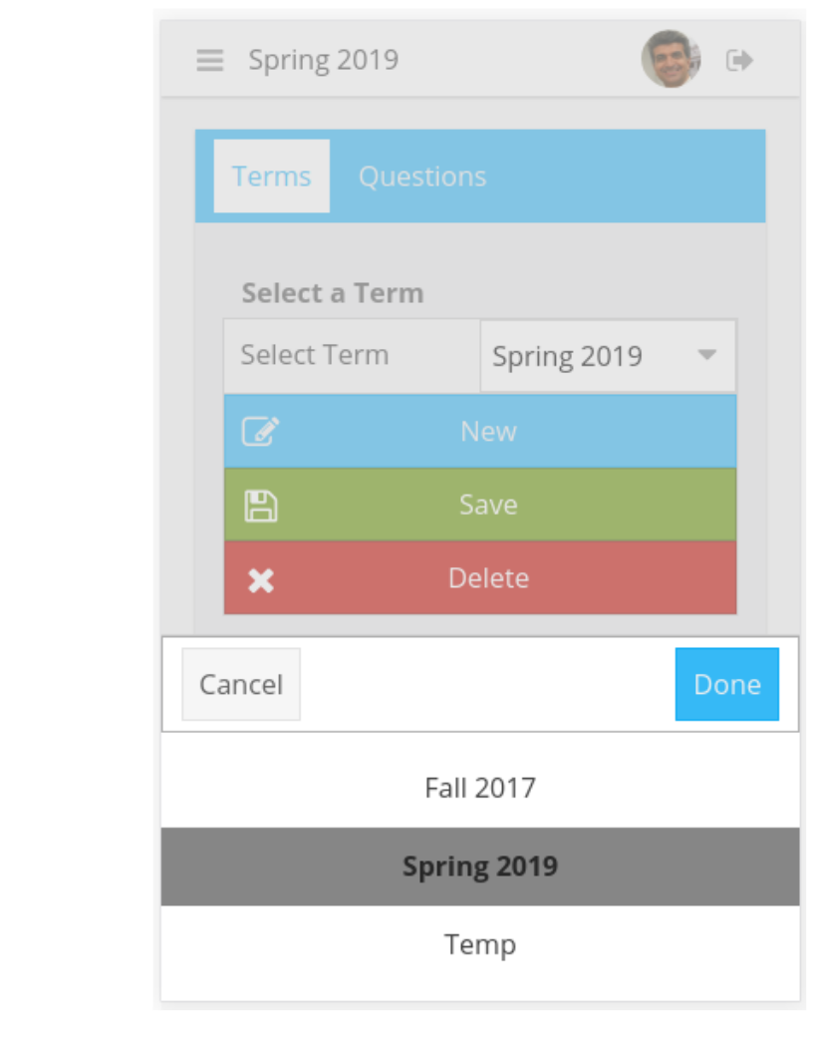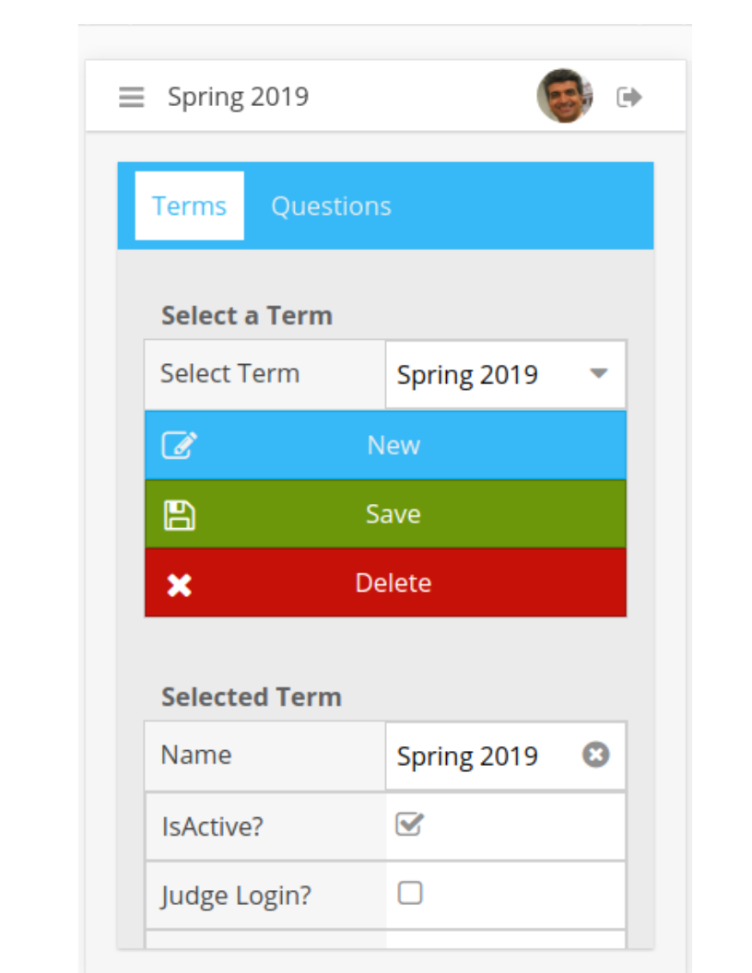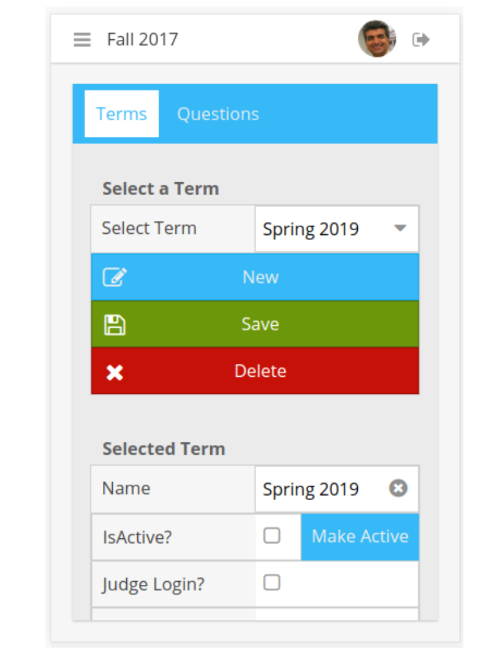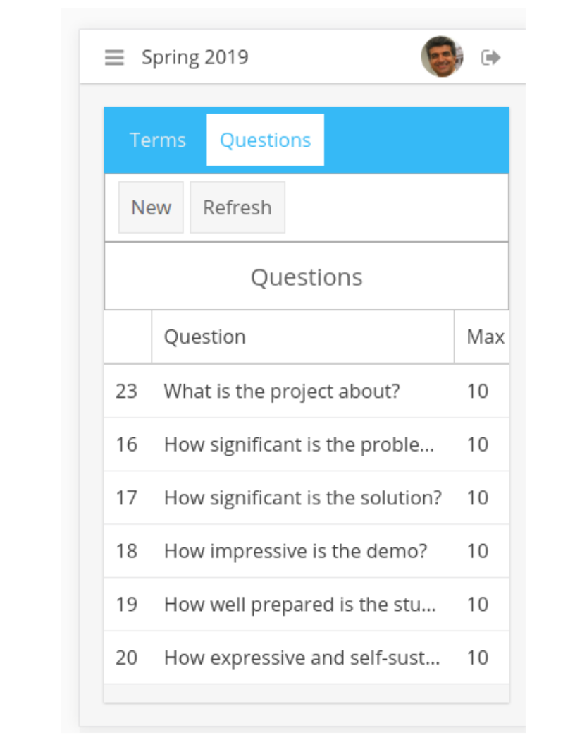

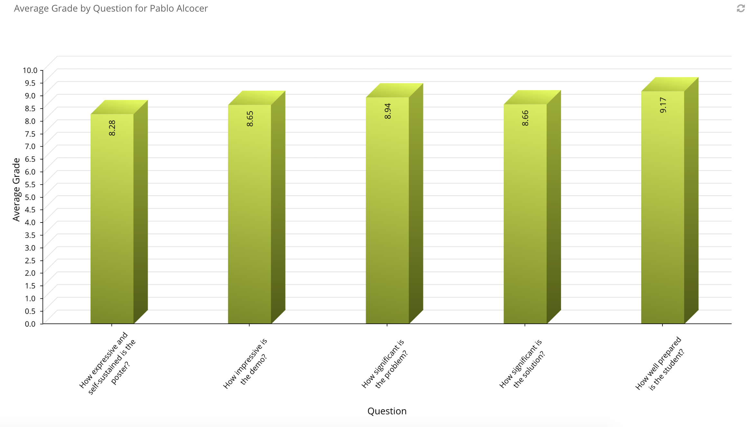

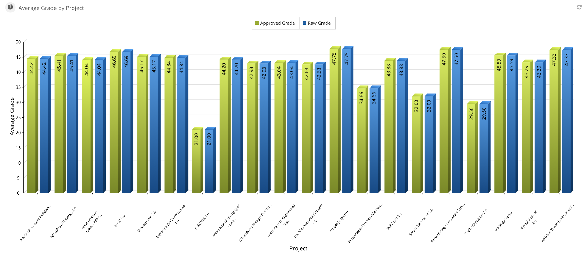

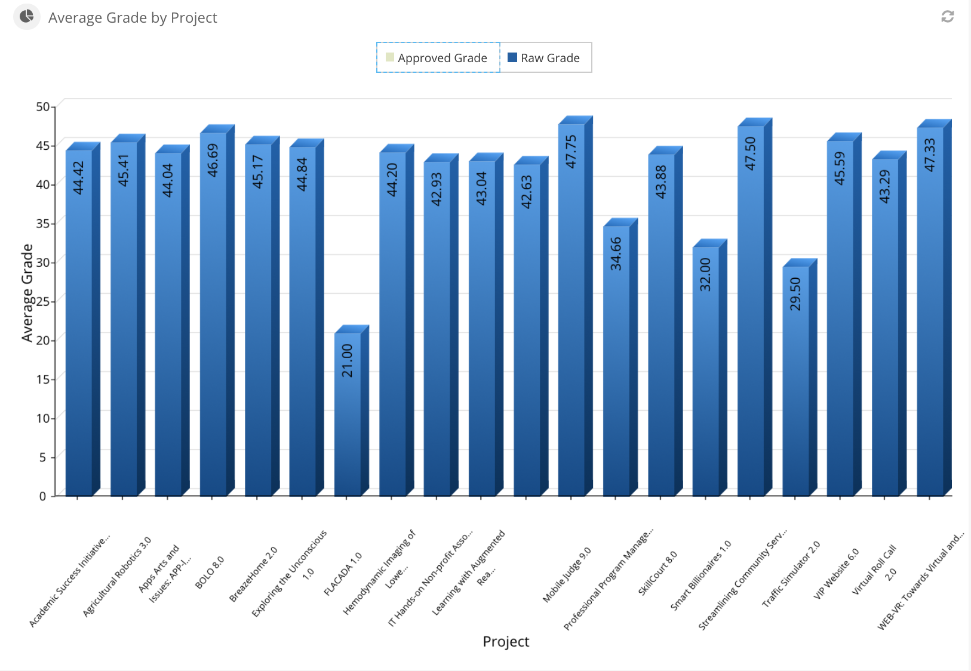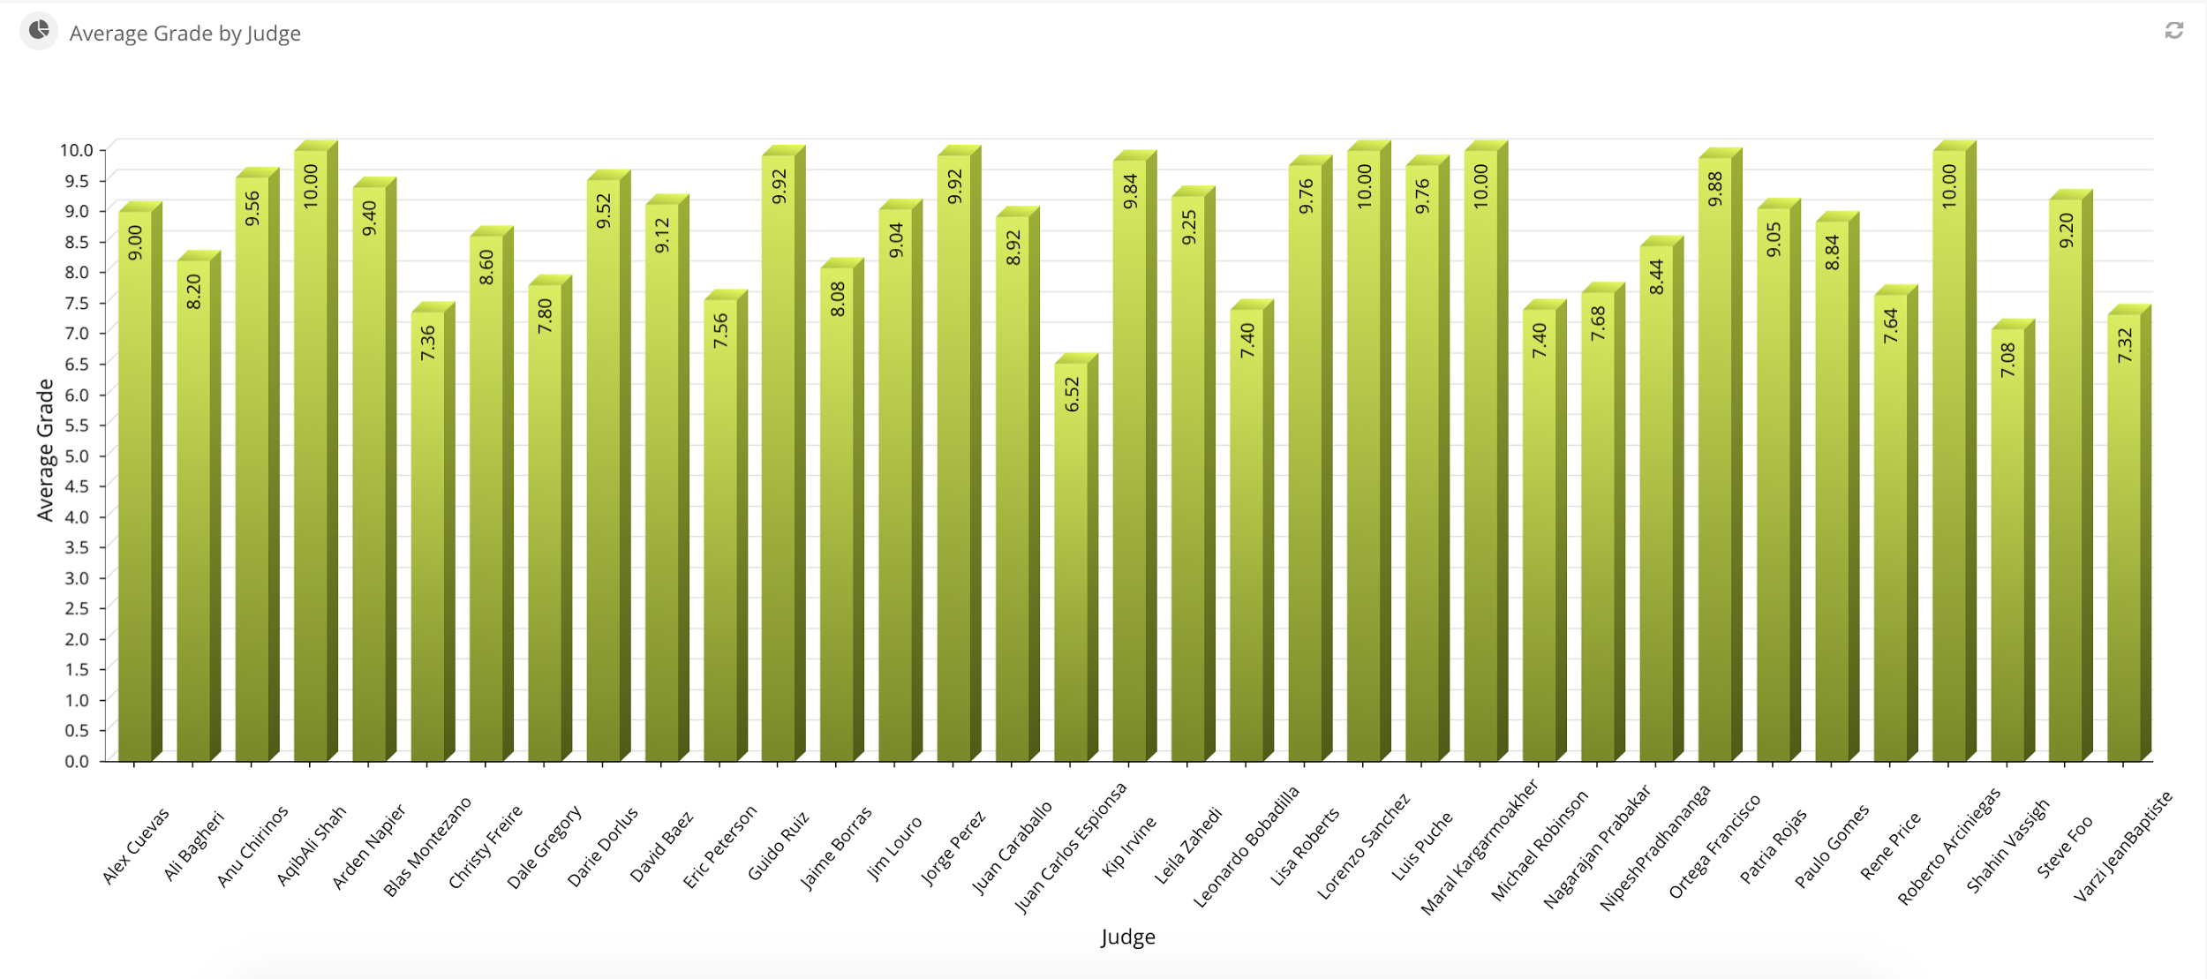

## 

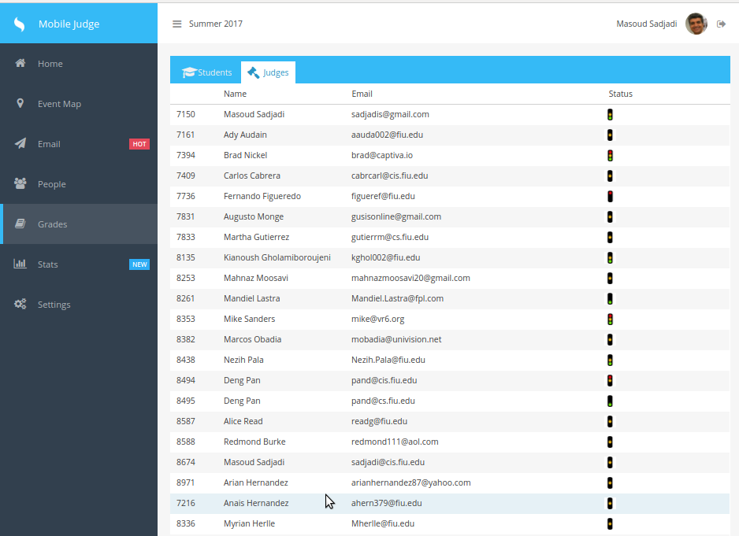

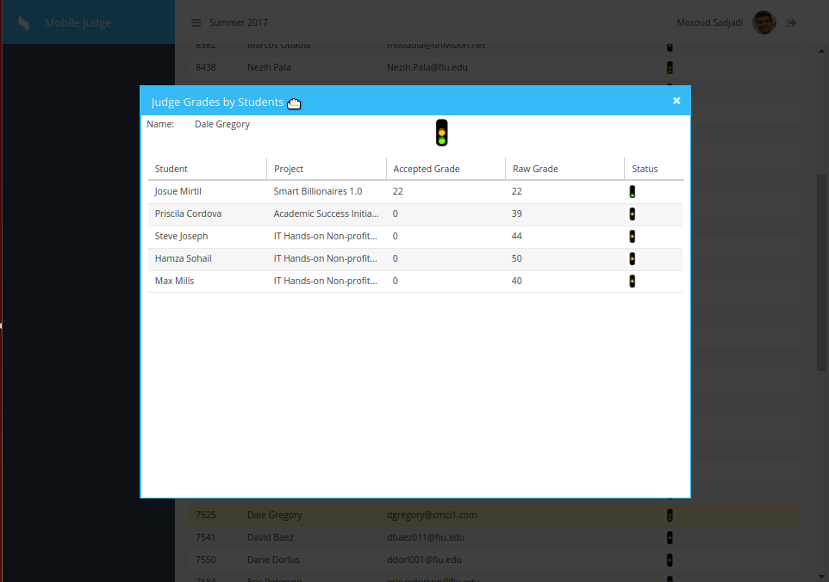

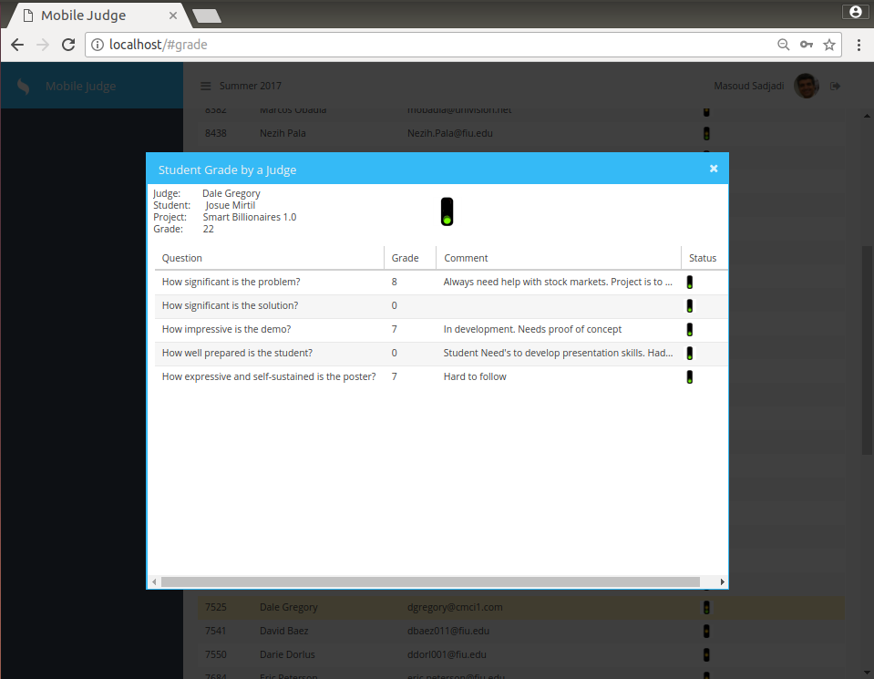

## Appendix C - Sprint Review Reports

## Sprint 2 Review Meeting Minutes

Attendees: Alberto Camacho, Guillermo Matos, Masoud Sadjadi, Pablo Alcocer, Shahinaz Elmahmoudi.

Start time: 4:00 PM

End time: 5:00 PM

After a show and tell presentation, the implementation of the following user stories were accepted by the product owners: All.

* No user stories were completed

The following ones were rejected and moved back to the product backlog to be assigned to a future sprint at a future Spring Planning meeting.

* No user stories were completed.

## Sprint 3 Review Meeting Minutes

Attendees: Alberto Camacho, Guillermo Matos, Masoud Sadjadi, Pablo Alcocer, Shahinaz Elmahmoudi.

Start time: 4:00 PM

End time: 5:00 PM

After a show and tell presentation, the implementation of the following user stories were accepted by the product owners:

* 692 Correcting mobile UI compatibility
* 693 Judge view by students
* 694 Accept judge invitation
* 698 Create stats views
* 699 Fix DB update

The following ones were rejected and moved back to the product backlog to be assigned to a future sprint at a future Spring Planning meeting.

* 695 Finish judge registration
* 697 Settings tab in mobile

## Sprint 4 Review Meeting Minutes

Attendees: Alberto Camacho, Guillermo Matos, Masoud Sadjadi, Pablo Alcocer, Shahinaz Elmahmoudi.

Start time: 4:00 PM

End time: 5:00 PM

After a show and tell presentation, the implementation of the following user stories were accepted by the product owners:

* User Story #700 Create Live Graphs for Admins
* User Story #701 Create Live Graphs for Students
* User Story #702 Fix Stop Light Issues
* User Story #703 Change Terms on Mobile Settings
* User Story #704 Create Terms on Mobile Settings
* User Story #705 Delete Terms on Mobile Settings
* User Story #706 Add Questions Mobile Settings
* User Story #707 Edit Questions Mobile Settings
* User Story #708 Delete Questions Mobile Settings
* User Story #709 Unregistered Judge Users
* User Story #710 Unregistered Judge Tab View

The following ones were rejected and moved back to the product backlog to be assigned to a future sprint at a future Spring Planning meeting.

Sprint 5 Review Meeting Minutes

Attendees: Alberto Camacho, Guillermo Matos, Masoud Sadjadi, Pablo Alcocer, Shahinaz Elmahmoudi.

Start time: 4:00 PM

End time: 5:00 PM

After a show and tell presentation, the implementation of the following user stories were accepted by the product owners:

* User Story #696 New registration process
* User Story #714 STATS - Average grade per question for all students (Admin View)
* User Story #722 STATS - Average grade per project (Admin View)

The following ones were rejected and moved back to the product backlog to be assigned to a future sprint at a future Spring Planning meeting.

* User Story #713 Support Multiple Classes per Semester
* User Story #711 Test and Fix defects for Admin Settings Page

## 

## Appendix D - User Manuals, Installation/Maintenance Document, Shortcomings/Wishlist Document and other documents

**Shortcomings/Wishlist**

There were a few items that were not completed:

* Adding stats live view
* Make Registration mobile compatible
* Make the Email Settings mobile compatible
* Make the Grades and People tabs mobile compatible

For the upcoming version of Mobile Judge, a few things that could be interesting to develop and implement are:

* Live Statistics during the Showcase
* Make everything compatible with mobile devices
* Allow administrator to change the role of users to admin, judge, or student
* Sync with VIP website

**Installation & Maintenance Document**

<https://www.sencha.com/products/extjs/#overview>

Documentation: <http://docs.sencha.com/extjs/6.0/>

Please follow the getting started guide: <http://docs.sencha.com/extjs/6.0/getting_started/getting_started.html>

But if you want to get a deep crash course of the framework follow this one instead:

<http://docs.sencha.com/extjs/6.0/getting_started/login_app.html>

Then I suggest head to the examples page and get familiar with the UI components (chances are you are going to end up adapting some of these to your own)

<http://examples.sencha.com/extjs/6.0.1/examples/>

**Note:** Don’t download the commercial version as indicated by the guides. Grab the GPL version from here instead: <https://www.sencha.com/legal/GPL/>

If the IDE of choice is WebStorm (which you can get a free student license from here <https://www.jetbrains.com/student/>) I suggest you install the ExtJS library since it can help in the inspection and autocompletion. If the option is not present click the Download button to the right.

**This guide is to setup our web server (NGINX) to serve as a front for static content (sencha files) and reverse proxy for nodejs (api / backend) and oauthd (oauth authentication). This will also host phpmyadmin to help on the db operations.**

1. **MariaDB 10.1**  
     
   To install MariaDB please go here <https://downloads.mariadb.org/mariadb/repositories/> and select the closest mirror and the appropriate binaries for your distribution. In my case I selected Ubuntu 14.04 “Trusty” and DigitalOcean NY as the mirror.  
     
   $ sudo apt-get install software-properties-common  
   $ sudo apt-key adv --recv-keys --keyserver hkp://keyserver.ubuntu.com:80 0xcbcb082a1bb943db  
   $ sudo add-apt-repository 'deb [arch=amd64,i386] http://nyc2.mirrors.digitalocean.com/mariadb/repo/10.1/ubuntu trusty main'  
     
   At this point follow the installation as you would with a mysql setup.  
   $ sudo apt-get update  
   $ sudo apt-get install mariadb-server  
   $ sudo mysql_secure_installation
2. **PhpMyAdmin**  
     
   $ sudo apt-get install php5-fpm php5-mysql php5-mcrypt  
     
   $ sudo vi /etc/php5/fpm/php.ini  
   Find the line with “;cgi.fix_pathinfo=1” replace it with “cgi.fix_pathinfo=0”  
     
   $ sudo php5enmod mcrypt  
   $ sudo service php5-fpm restart  
     
   $ sudo apt-get install phpmyadmin  
     
   Do not check any of the web servers as nginx is not part of the list.   
   Check yes to “Configure database for phpmyadmin with dbconfig-common?”  
   It will also ask for the root password that you specified above and set a new one for the phpmyadmin user (it can be the same one but for security it should be different)
3. **NGINX**  
     
   $ sudo apt-get install nginx  
     
   Add some fonts mime types to nginx:  
     
   $ sudo vi /etc/nginx/mime.types  
     
   font/ttf ttf;  
   font/opentype otf;  
   application/font-woff woff;  
   application/vnd.ms-fontobject eot;  
     
   Add “client_max_body_size 5M;” before the include of mime types:  
   $ sudo vi /etc/nginx/nginx.conf  
     
   Setup the site configuration as the one I’ve uploaded to this folder:  
   $ sudo vi /etc/nginx/sites-enabled/default  
     
   Symlink phpmyadmin into your nginx root directory  
   $ sudo ln -s /usr/share/phpmyadmin /usr/share/nginx/html  
     
   Apache may still be running. Check with this command  
   $ service --status-all  
     
   Stop apache2 if running  
   $ sudo service apache2 stop  
     
   Restart and browse to http://yourserverip/ and <http://yourserverip/phpmyadmin/>  
   $ sudo service nginx restart

**OAuthd admin**To be able to access the oauthd instance just remove or rename the config.local.js from the oauthd folder. This will reset all the bindings to listen to all ip address instead of just localhost. After working with the admin, restore the config.local.js to its original so the admin is not accessible from outside.

You can access the admin site at c

username: [sadjadi@cs.fiu.edu](mailto:sadjadi@cs.fiu.edu)

password: Judge2015

We are using the following keys:

|  |  |  |  |  |
| --- | --- | --- | --- | --- |
| **Provider** | **ClientId** | **Secret** | **Scope** | **Extra** |
| LinkedIn2 | 77f7r4zh0rdc5s | TcWFVKGW3OnP0lDz | r_basicprofile, r_emailaddress |  |
| Twitter | IxufoHxASt5wkzLr9MpMJw754 | SYi8X9t8x0bHRCbOy9xhATwvoznKfIJ5Jry4Y5n1roAz2gDx95 |  |  |
| Facebook | 1657227221222913 | 97979fb246a2c3fbb7444dfbb6b151b4 | email, user_about_me | api_version: v2.3 |
| Google | 153038497251-idf2tmj  3hljvdppk5g5tr6jb849q91st.apps.googleusercontent.com | MiEkCeUXVF6Lza9Gdkp_D-A_ | openid, email, https://www.googleapis.com/auth/userinfo.profile | access_type: online |
| FIU | same as above | | | domain: fiu.edu |

The site will look like this:

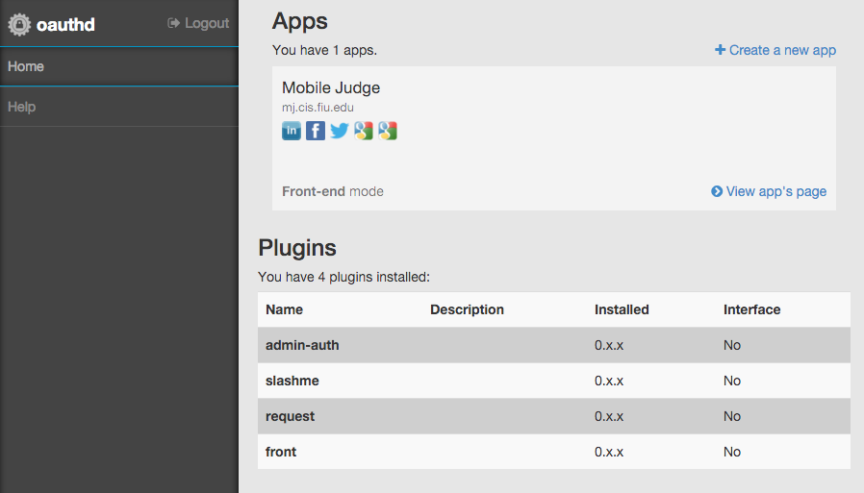

**This guide is to show how to build the sencha app and deploy it to site along with the nodejs backend.**

1. **Sencha Cmd**$ wget <http://cdn.sencha.com/cmd/6.0.2/no-jre/SenchaCmd-6.0.2-linux-amd64.sh.zip>  
   $ unzip SenchaCmd-6.0.2-linux-amd64.sh.zip  
   $ sudo apt-get install default-jre  
   $ ./SenchaCmd-6.0.2.14-linux-amd64.sh  
   $ sencha  
   Sencha Cmd v6.0.2.14  
   …  
   (If the sencha command does not work, run ‘source .bash_profile’)  
     
   Quick overview of Sencha Cmd can be found here: <https://www.sencha.com/blog/sencha-cmd-enterprise-workflow/>
2. **Build production version**If you followed the [getting started guide](http://docs.sencha.com/extjs/6.0/getting_started/getting_started.html) for the Sencha Framework you should have a folder structure with everything in place. Next you can grab the code from the git repo and overwrite everything there and do  
      
    $ sencha app refresh  
    $ sencha app build production  
     
   The minified version of your app with all the styles and toolkits compiled is under the build/production folder. One hint of advice right after building a production version execute the following to reset back your workspace to a development mode.  
     
    $ sencha app build development
3. **Deploy  
   (**the api folder (is the output) will be named server in the MobileJudge directory, and copy over client/build/production/\***)**Deployment is very easy:   
   - Copy the output from the sencha cmd above under the root of your nginx server (usually /usr/share/nginx/html).  
   - Copy the api folder to the same folder as above and execute “npm install” (if you include the node_modules folder then no need for last).  
   - Deploy the database either using phpmyadmin or the mysql cli tool.  
   - Update the api/config/database.json file accordingly. prt   
   - Start the backends with either one of these options (first 2 are for dev/test)  
    $ node index.js  
    $ nodemon index.js  
    $ pm2 start index.js --watch
4. **Node Process Management & Server Monitoring (PM2)**Create an account at <https://app.keymetrics.io> This will allow us to monitor the health of the server remotely and inspect what’s is happening with out backend. It will also allow to keep the node applications running and restart them in the event of a server failure or any file is updated (handy for deploy).Documentation and quick start reference: <http://docs.keymetrics.io/> <http://pm2.keymetrics.io/docs/usage/quick-start/>   
   **Note**: the keys provided here are for the VIP Senior Project bucket. I will send invitations to all of you so you guys can join it.  
   $ wget -qO- http://install.keymetrics.io/install.sh | SECRET_ID=c4oqalvhmicddmz PUBLIC_ID=7wu2tbb2eyc6sh1 sudo bash  
   $ sudo pm2 link c4oqalvhmicddmz 7wu2tbb2eyc6sh1 mj.cis.fiu.edu  
   $ sudo pm2 install pm2-server-monit  
   $ sudo pm2 install pm2-mysql  
   $ sudo pm2 install pm2-redis  
   $ sudo pm2 set pm2:passwd Judge2016  
     
   $ cd /usr/share/nginx/html/api  
   $ sudo pm2 start index.js -i 0 --watch --name "mj-api"  
   $ cd /usr/share/nginx/html/oauthd  
   $ sudo pm2 start index.js -i 0 --watch --name "mj-oauthd"  
     
   $ sudo pm2 save  
   $ sudo pm2 startup ubuntu
5. **Smtp Relay Setup  
     
   Live**$ sudo apt-get install sendmail  
   $ sudo sendmailconfig  
     
   $ sudo vi /etc/mail/sendmail.mc  
   Add   
    define(`SMART_HOST', `mail.cs.fiu.edu')dnl  
   before  
    MAILER_DEFINITIONS  
     
   $ sudo /etc/init.d/sendmail restart  
    **Test/Dev**For development and testing pusposes in order to test the email functionality but no sending emails out you can either fake the smtp host above with your own smtp server or use a redirect/captcha like explained here <http://distinctplace.com/2013/06/20/nullmailer-and-fake-mail---two-little-tools-for-every-developer/>

# References

Mobile Judge 9: [LINK](https://github.com/FIU-SCIS-Senior-Projects/Mobile-Judge-9.0)

Mobile Judge 8: [LINK](https://github.com/FIU-SCIS-Senior-Projects/MobileJudge8)

Mobile Judge 7: Frank Hernandez: [LINK](https://drive.google.com/open?id=0B457zg45quzrZjl5Nm5GUW81b0k)